Factor: Factor:
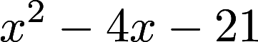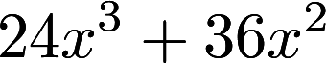

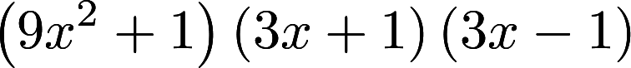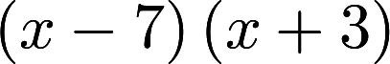

Factor: Factor:
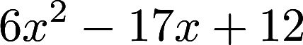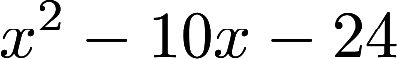

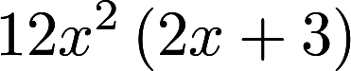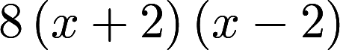
Factor: Factor:
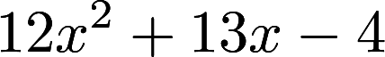

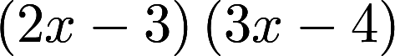

The area of a rectangle is The area of a rectangle is
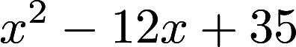. What are the 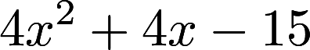. What is the
dimensions of the rectangle. perimeter of the rectangle?

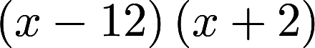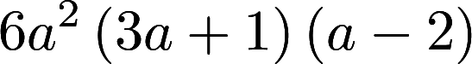
Factor Completely: Factor Completely:
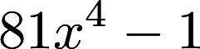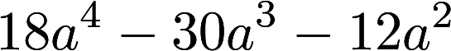

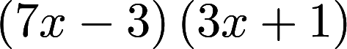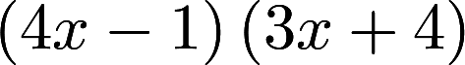
The volume of a rectangular Factor:
prism is 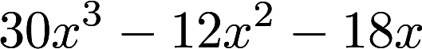. What
are the dimensions of the 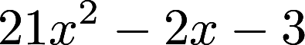
rectangular prism?

