Math 1: Unit 10 Study Guide: Inequalities ____________________________________________
- Which systems of inequalities matches the graph provided?
- y < -2/3x+2 B. y < -3/2x+3 C. y < -2x+3 D. y < -2/3x+2
y < -1/4x y > -1/4x y < -4x y < 1/4x

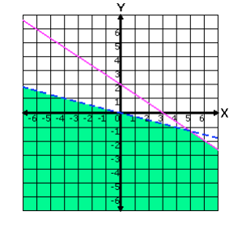

- Is (-2, 3) a solution of the given system:

$2x-y≤0$
$2y-x≥-4$
$x<4-y$

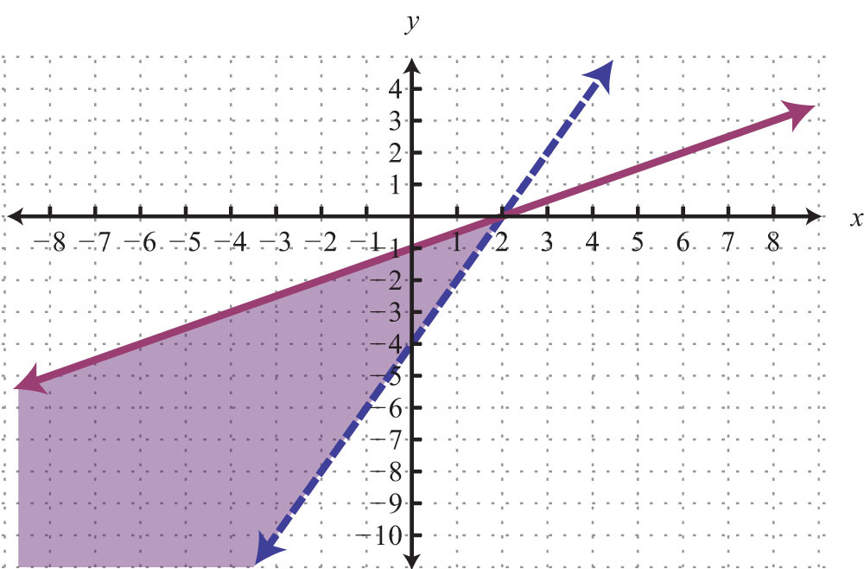

3. Which is not a solution to the graph.
a. (-2, -4) b. (4, 2)
c. (-4, -3) d. (1, -1)

4. The owner of Gibby’s Fish Fry orders flounder and perch. He wants to buy at least 75 pounds of fish but cannot spend more than $550. Flounder is $10.00 per pound and perch is $6.00 per pound. Write a system of inequalities to model this scenario.

5. Which is the graph of the solution set of the system of inequalities?
y > 2/3x
y < 2
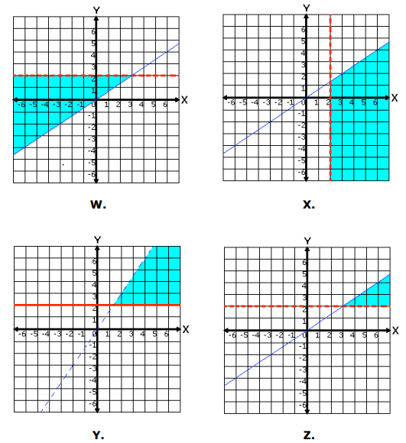

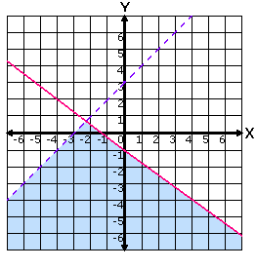
6. . . Which system is graphed to the right?
A. $x-y>-3$
$3x+4y≤-4$

B. y$>x+3$
$y≤4x-1$

C. $y-x>-3$
$2x+4y≤4$

7. Northcross Bowling charges a $50 flat fee for a birthday party rental and $4 for each person to bowl. Gary can spend at most 100 dollars for his party. Write an inequality that models this situation

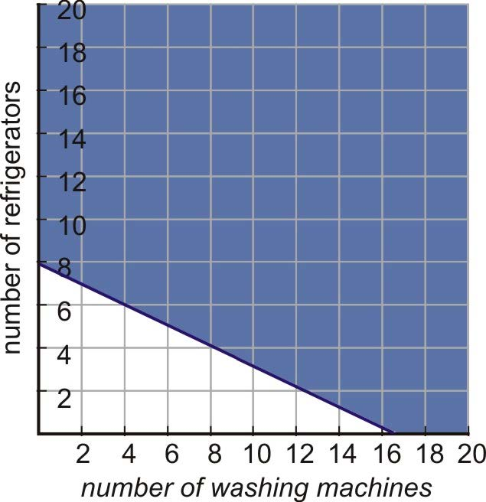
8.

A. Two times the number of refrigerators, y, plus the number of washing machines, x, is at least 16.
B. Two times the number of refrigerators, y, plus the number of washing machines, x, is at least 8.
C. Two times the number of refrigerators, y, minus the number of washing machines, x, is at least 16.
D. Two times the number of refrigerators, y, minus the number of washing machines, x, is at least 8.

9. Which inequality represents the scenario portrayed by the graph?
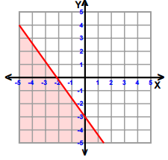
- y < -7/5x-2 B. y < -5/7x-3 C. y > 7/5x-3 D. y < -7/5x-3

10. Given the following system of equations:
x = 6y – 5
-5x + 3y = -29
What is the value of x + y ?

11. What is the solution to the following system?
3x + 2y = 11
9x – 5y = 55

12. Write the slope for a line perpendicular to $y=-3x+2$

13. Find the difference of the y-intercepts when you subtract the y-intercept of f(x) from the y-intercept of g(x)
x | -2 | 3 | 4 | 6 | 8
y | 4 | 14 | 16 | 20 | 24
g(x): $5x-10y=20$ f(x):

14. The length of the rectangle is 4 more than three times the width. What is the expression for the perimeter of the rectangle.

15. The sum of three consecutive even integers is 72. What is the smallest integer?

16.
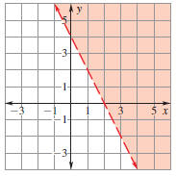
All of the following are solutions to the given graph except?

- (3, 3) b. (5, -3)
c. (0, 5) d. (2, 0)

