Math I Unit 9 Study Guide Name______________________________

OBJ. 1: Quadratic Functions

1. Given: ${f\left(x\right)= -x}^{2}-6x-8$
How does the graph open? | Up or Down
Does it have a Min or Max? | Min or Max
State the y-intercept
State the Axis of Symmetry
State the Vertex
State the Solutions
State the Domain
State the Range

2. Given $0=x^{2}-25$
How does the graph open? | Up or Down
Does it have a Min or Max? | Min or Max
State the y-intercept
State the Axis of Symmetry
State the Vertex
State the Solutions
State the Domain
State the Range

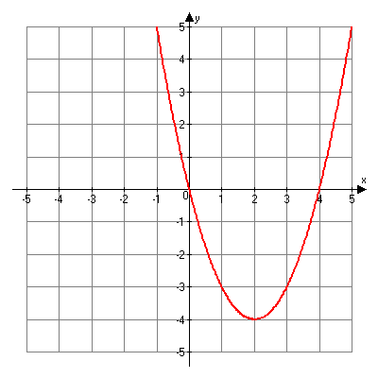
3. Given: $-2x^{2}+8x+24=0$
How does the graph open? | Up or Down
Does it have a Min or Max? | Min or Max
State the y-intercept
State the Axis of Symmetry
State the Vertex
State the Solutions
State the Domain
State the Range

4. Given the graph at the right
How does the graph open? | Up or Down
Does it have a Min or Max? | Min or Max
State the y-intercept
State the Axis of Symmetry
State the Vertex
State the Solutions
State the Domain
State the Range

OBJ. 2: Quadratic Functions: Vertex and Axis of Symmetry
9. Which of the following is the graph of the function f(x) = 2x² + 3x + 4?

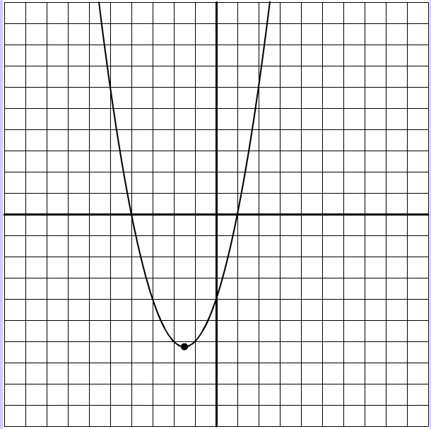
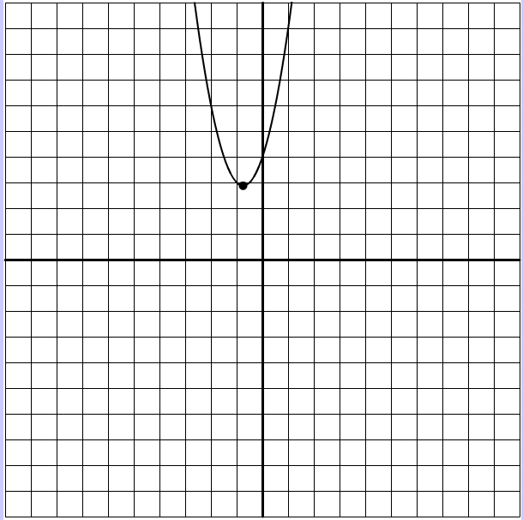
  - B.

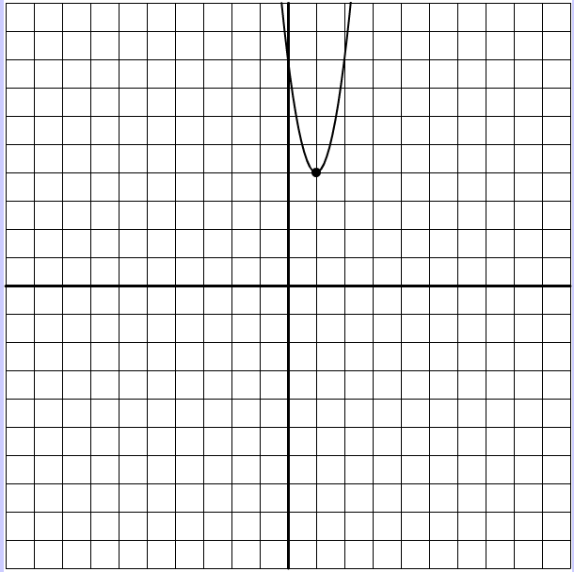
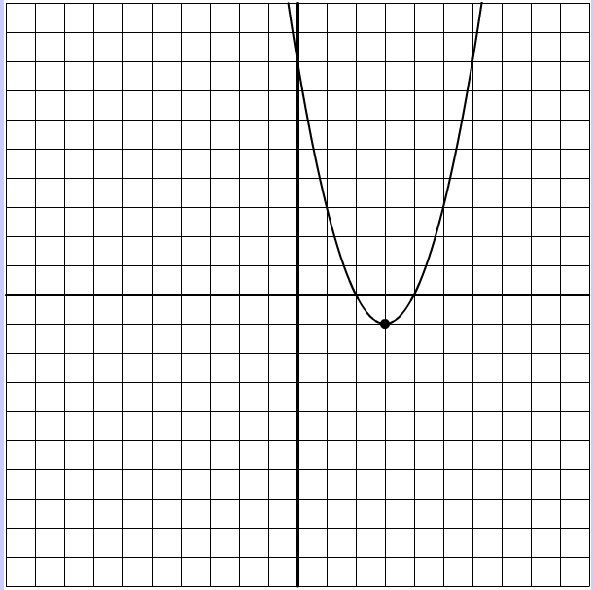

C. D.

10. Which best describes the graph of the equation f(x) = 2x² + 12x + 3 ?
  - Vertex is (3, 57), it opens up and has a minimum.
  - Vertex is (3, 57), it opens down and has a minimum
  - Vertex is (-3, -15), it opens down and has a maximum
  - Vertex is (-3,-15), it opens up and has a minimum
  - Vertex is (-3, -51), it opens up and has a maximum
11. What are the roots (solutions) of f(x) = x² + 4x – 12

12. A company models its net income with the function,$f\left(x\right)=3x^{2}-18x-48$ where x is the number of units sold. How many units of its product does the company need to sell in order for the net income to equal $0

