Inverse Functions Study Guide
To find the inverse of a function,  - Switch x and y values  - Solve for y  Inverse notation: $f^{-1}(x)$ | Find the inverse of each function:  $$f\left(x\right)=2x^{2}-8$$  $$f\left(x\right)=4x+2$$  $$f\left(x\right)=\frac{2}{3}x+6$$  $$f\left(x\right)={(x-1)}^{2}+4$$  $$f\left(x\right)=\sqrt{2x-1}$$  $$f\left(x\right)= \frac{4}{x+2}$$
One to One functions:  Functions that pass both the vertical and the horizontal line test | Determine if these functions are one to one:  f(x) = 3x + 4  f(x) = (x + 2)²  f(x) = $\frac{2}{3}x+5$  $$f\left(x\right)= \sqrt{x-7}$$
Domain and Range of Inverse Functions  Remember that the domain and range of the function are the range and domain of its inverse  You have to restrict the domain of the function, to ensure that the inverse is a function as well. | Find the domain and range of the given function and its inverse function. Restrict the domain where necessary.  f(x) = (x – 4)²  f(x) = 6x – 1  $f\left(x\right)= \sqrt{x+4}$
Composite functions  Functions are inverses of each other if  $$fog\left(x\right)=gof\left(x\right)=x$$  Or f(g(x)) = (gf(x)) = x | Verify that the functions are inverses of each other.  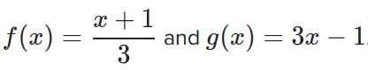  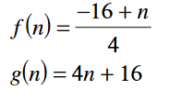
Inverses from tables and graphs | 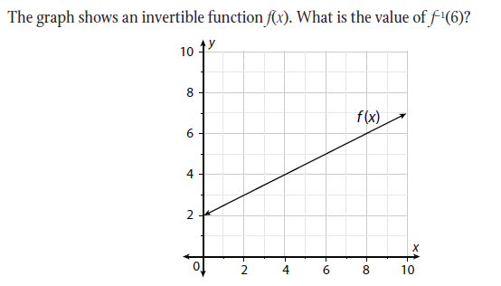  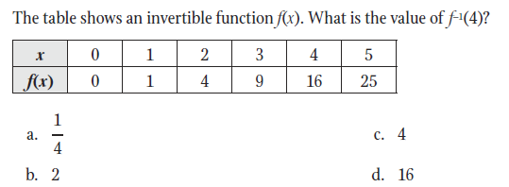  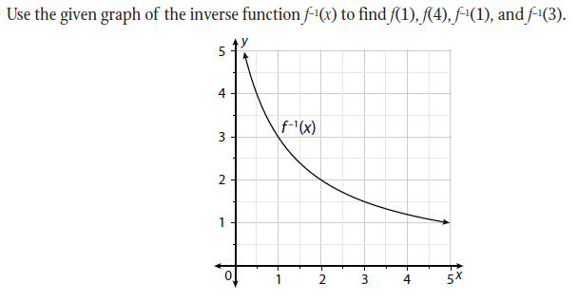
Evaluating Inverses  If g is the inverse of f and f(9)=5, what is f(9) + g(5)?  Since f(9)=5 then g(5)=9  5 + 9 = 14 | Using the same values as in the example.  Find 3f(9).  Find f(9) – g(5).

