Study Guide Name _______________________________
Trigonometry Fall 2018 Date ________________________________

- Convert $\frac{7π}{15}$ to degree measure.

- If m∠θ = $\frac{10π}{9}$ radians, what is the measure of its reference angle?

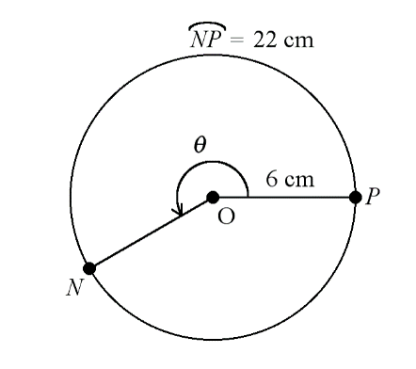
- What is the measure of the angle shown in radians?

- In which quadrant of the unit circle does the terminal side of an angle measuring $\frac{4π}{3}$ radians fall?

- Find the reference angle for 200°.

- Convert 55° to radians.

- What is cos $\frac{2π}{3}$?

- What is sin $\frac{4π}{3}$?

- What is sin $\frac{5π}{6}$ ?

- What is the amplitude of the function f(x) = 7 cos [5(x + 6)] + 1?
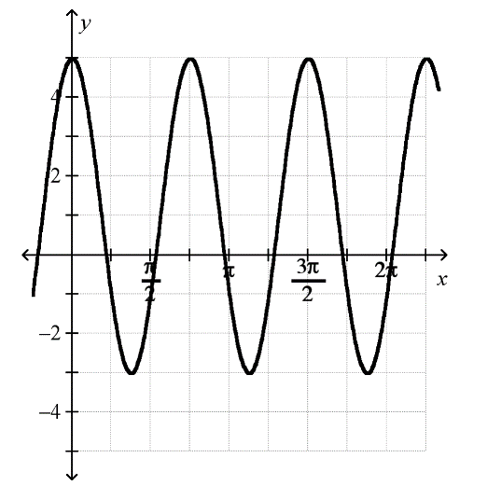
- What is the frequency of the function shown in the graph?

- What is the equation of the function shown in the graph?

- What is the midline of the function f(x) = −2 sin 5[ x + 4] + 3?

- What is the equation of a sine function that has no horizontal displacement, rises 4 units above its midline, is at y = 3, and has a period of $\frac{π}{5}$?

- What is the frequency of the function f (x) = 5 sin (2x) − 4?

- What is the period of the function f (x) = -2 cos ($\frac{3x}{5}$) + $π$?

- What is the amplitude of the function shown in the graph?

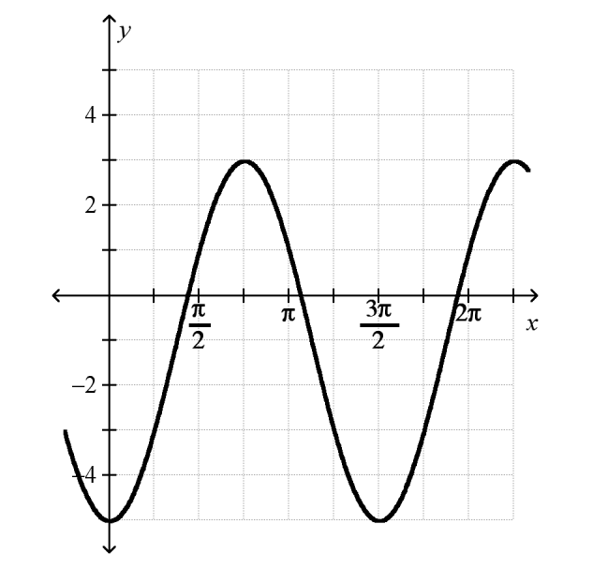

- A function, f(x) = A cos (Bx) +H, has the following properties:
- a period of 4
- a minimum value of -1
- f(1.15)=1.3 and
- A, B and H are all positive constants.
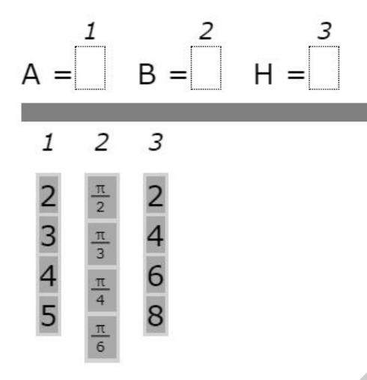
Place (click and drag) values into the appropriate cells below that will create this function.

