Math 1: Unit 3 Study Guide Student Name:_________________________________
OBJ. 1: Solving Systems
Objective | Score
1 | A B NY
2 | A B NY
3 | A B NY
4 | A B NY
5 | A B NY
ANSWERS:
1.

2.

3.

4.

4/4 = 100 | 3/4 = 80 | 0-2 = NY
5.

6.

7.

8.

4/4 = 100 | 3/4 = 80 | 0-2 = NY
9.

10.
11.

12.

4/4 = 100 | 3/4 = 80 | 0-2 = NY
13.

14.

15.

16. graph

4/4 = 100 | 3/4 = 80 | 0-2 = NY
17
18.

19.

20.

4/4 = 100 | 3/4 = 80 | 0-2 = NY

Solve the following systems:
1. y = - x + 6 2. x = 11 + y 3. 8x + y = -16 4. 2x + 4y = 8
y = 3x – 2 2x + y = 4 –3x + y = -5 3x + 3y = 9

OBJ. 2: System Word Problems
5. Nine times Antonio’s age plus 5 times Kim’s age equals 144. Kim’s age is also 3 times Antonio’s age. How old is Kim?
6. The sum of two numbers is 90. The second number is equal to fourteen times the first number. What are the two numbers?
7. Lena and Doug are selling tee shirts and sweatshirts for a school fundraiser. Customers can buy tee shirts and sweatshirts. Lena sold 6 tee shirts and 3 sweatshirts for a total of $126. Doug sold 2 tee shirts and 5 sweatshirts for a total of $114. What is the cost each of one tee shirt and one sweatshirt?
8. A test has 20 questions worth 100 points. The test consists of True/False questions worth 3 points each and multiple choice questions worth 11 points each. How many multiple choice questions are on the test?

OBJ. 3: Inequalities

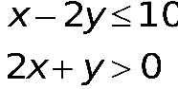
9. Which is the graph of the solution set of the system of inequalities?
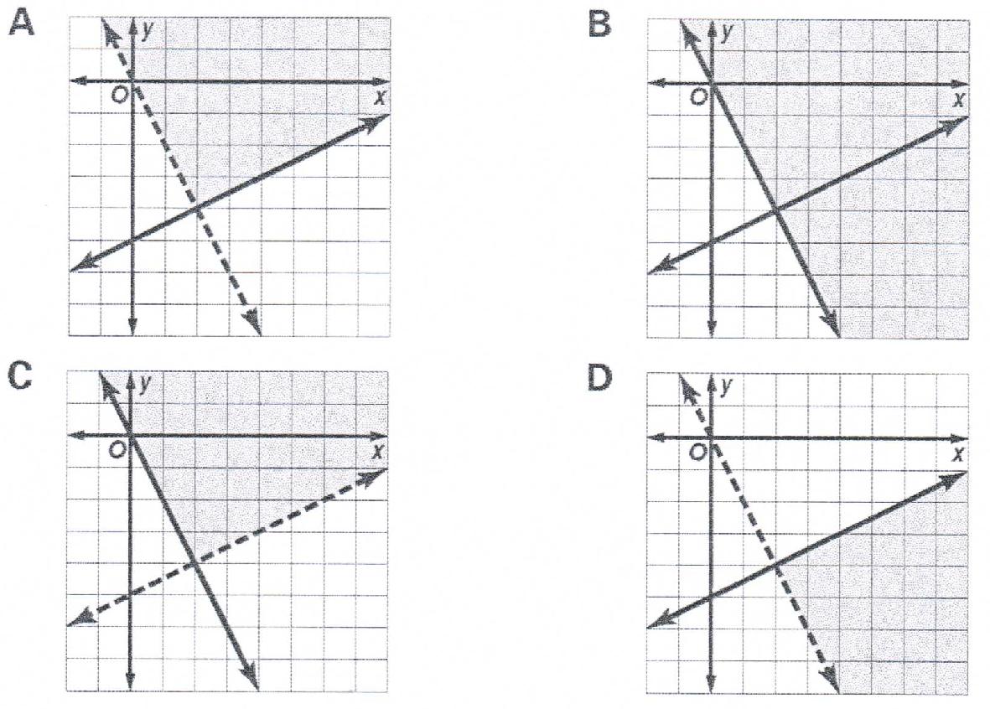
10. Is (-2, 3) a solution of the given system:

$2x-y≤0$
$2y-x≥-4$
$x<4-y$

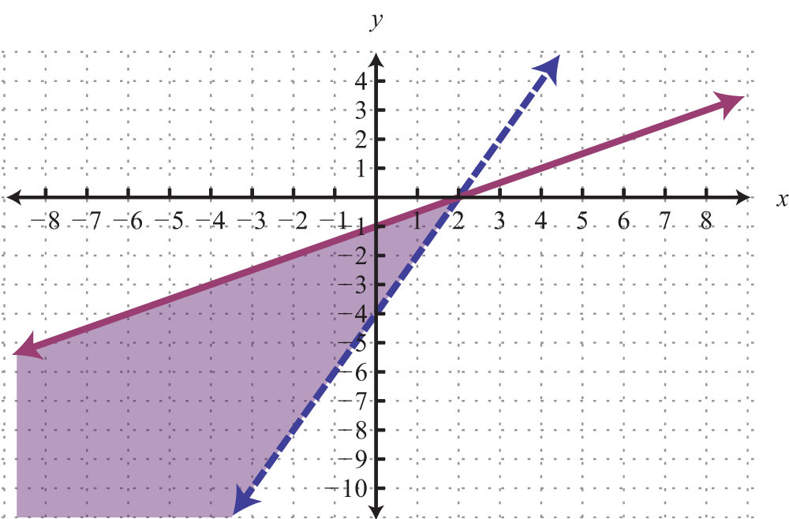
11. Which is not a solution to the graph.
a. (-2, -4) b. (4, 2)
c. (-4, -3) d. (1, -1)

12. The owner of Gibby’s Fish Fry orders flounder and perch. He wants to buy at least 75 pounds of fish but cannot spend more than $550. Flounder is $10.00 per pound and perch is $6.00 per pound. Write a system of inequalities to model this scenario.

OBJ. 4 Review

13. Write the equation of a line perpendicular to $2x-5y=10$ and goes through the point, (4, 8).

14. Gregory teaches martial arts. He charges a one-time processing fee of $3.00 and the cost of the classes is shown below. Let x represent the number of classes and y represent the cost of classes.
Number of Classes, x | 1 | 2 | 3 | 4
Cost of Classes(not including processing fee), y | $15.00 | $27.00 | $39.00 | $51.00
Based on this information, what will it cost to take 10 classes?
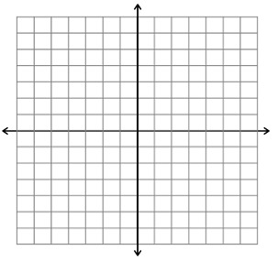
15. Graph: $6x - 3y = 18$

16. Find the largest of 3 consecutive integers such that 3 times the largest is the same as 5 less than twice the middle.

Math 1: Unit 3 Study Guide
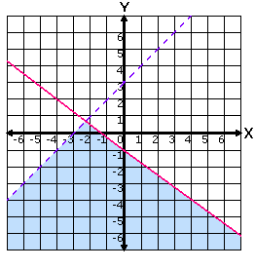
OBJ. 5: Calculator Inactive

17. Which system is graphed to the right?
A. $x-y>-3$
$3x+4y≤-4$

B. y$>x+3$
$y≤4x-1$

C. $y-x>-3$
$2x+4y≤4$

18. The math club sells hotdogs and drinks during football games.
- 100 hotdogs and 400 drinks will sell for $500
- 150 hotdogs and 200 drinks will sell for $450
How much does each hotdog sell for?

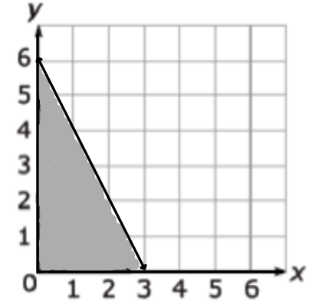
19. Which scenario can be modeled by the graph below?
A. The number of pounds of candy, y, minus two times the number of pounds of gum, x, is at most 6.
B. The number of pounds of candy, y, minus half the number of pounds of gum, x, is at most 6.
C. The number of pounds of candy, y, plus two times the number of pounds of gum, x, is at most 6.
D. The number of pounds of candy, y, plus half the number of pounds of gum, x, is at most 6.

20. The Hill family needs a vacation. They plan on renting an RV. Momma Hill wants the best deal, when she calls to inquire about rates, she receives the following information:
- RV 4 U charges an initial fee of $2000 and $2.00 per mile driven
- We are RV does not charge an initial fee but charges 4.00 per mile driven
After how many miles will the two companies cost the same?

