Math I Unit 6 Study Guide
Teacher:___________________________________ Student Name:______________________________
Objective | Score
1 | A B NY
2 | A B NY
3 | A B NY
4 | A B NY
5 | A B NY
ANSWERS:
1.

2.

3.

4.

4/4 = 100 | 3/4 = 80 | 0-2 = NY
5.

6.

7.
SH = MH =
8.

4/4 = 100 | 3/4 = 80 | 0-2 = NY
9.

10.

11.

12.

4/4 = 100 | 3/4 = 80 | 0-2 = NY
13.

14.

15.

16.

4/4 = 100 | 3/4 = 80 | 0-2 = NY

OBJ. 1: Solving Quadratic Functions (Use any method)
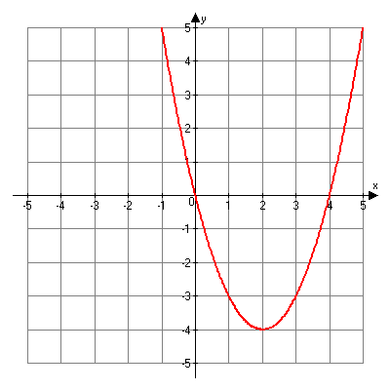
1. x²+6x+8=0 2. 4x²=100

3. 2x² + 10x + 9 = -2x²- 7x + 5

4. What are the solutions(x-intercepts) to the
graph at the right?

OBJ. 2: Projectile Motion Application
5. The height of an object thrown into the air is given by the formula $h\left(t\right)= -16t^{2}+801t$, where h(t) is in feet and t is in seconds. What is the height of the object after 3 seconds?

Use the following for 6-8: A ball is thrown into the air with an upward velocity of 64 ft/s. Its height h in feet after t seconds is given by the function .

6. In how many seconds will the ball reach its maximum height? Round to the nearest hundredth if necessary.

7. What is the starting height? What is the ball’s maximum height?

8. After how many seconds will the ball hit the ground?

OBJ. 3: Review
9. Simplify: (2x³y²)⁻⁴ (3x⁵y²)²
10. Given the volume of a rectangular prism: 6x³ + 43x² + 7x, find possible dimensions for the length, width and height.

11. Find the sum of x and y, given: $2x-3y=15$
$$x+y=5$$

12. Find the area of the shaded region.

x-1

2x+5
x+4

3x+1

OBJ. 4: Quadratic Functions: Vertex and Axis of Symmetry
- Which of the following is the graph of the function f (x) = 2x² + 3x + 4?

  - B.
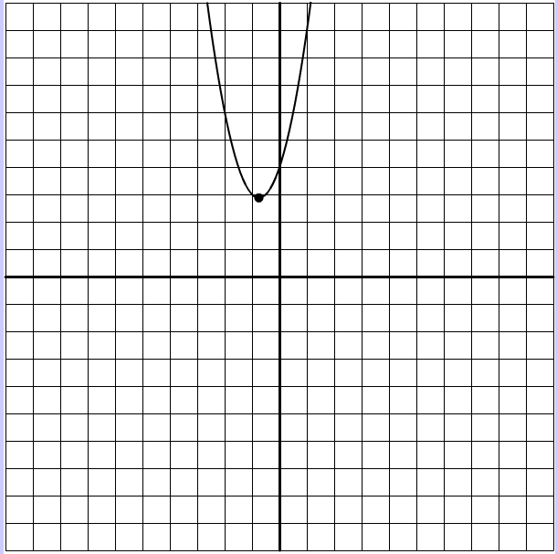
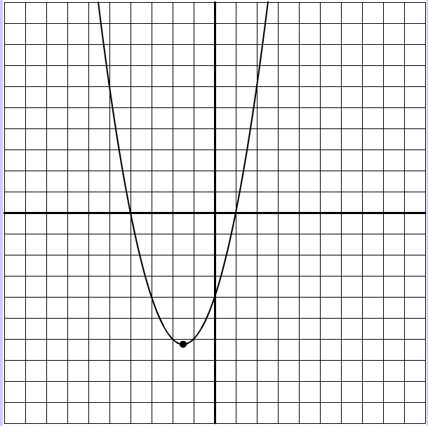

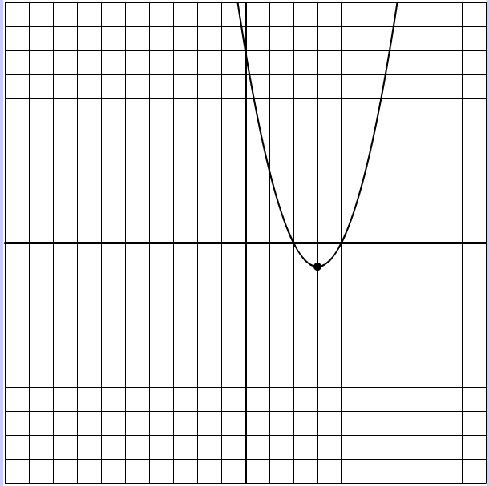
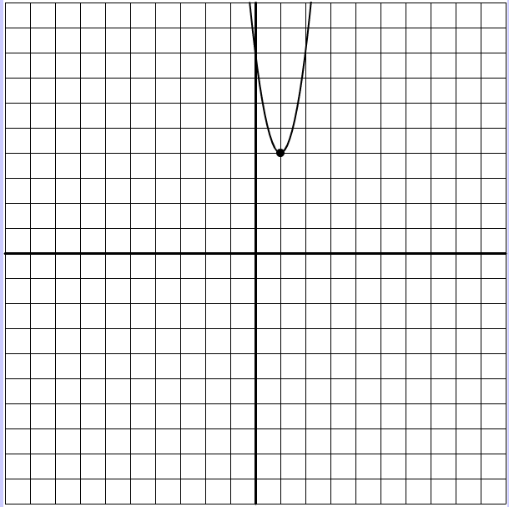
C. D.

- Which best describes the graph of the equation f(x) = 2x² + 12x + 3 ?
  - Vertex is (3, 57), it opens up and has a minimum.
  - Vertex is (3, 57), it opens down and has a minimum
  - Vertex is (-3, -15), it opens down and has a maximum
  - Vertex is (-3,-15), it opens up and has a minimum
  - Vertex is (-3, -51), it opens up and has a maximum

- What are the roots(solutions) of f(x) = x² + 4x – 12 ?

- The function h(t) = -6t² +56t + 85 models the approximate height of an object seconds after it is launched. What was the height of the object when it was launched?

