Math I Unit 7 Study Guide Student Name:____________________________

|  |  |
| --- | --- |
| **Objective** | **Score** |
| 1 | A B NY |
| 2 | A B NY |
| 3 | A B NY |
| 4 | A B NY |
| 5 | A B NY |

ANSWERS:

|  |  |  |
| --- | --- | --- |
| **1.** | | |
| **2.** | | |
| **3.** | | |
| **4.** | | |
| **4/4 = 100** | **3/4 = 80** | **0-2 = NY** |
| **5.** | | |
| **6.** | | |
| **7.** | | |
| **8.** | | |
| **4/4 = 100** | **3/4 = 80** | **0-2 = NY** |
| **9.** | | |
| **10.** | | |
| **11.** | | |
| **12.** | | |
| **4/4 = 100** | **3/4 = 80** | **0-2 = NY** |
| **13.** | | |
| **14.** | | |
| **15.** | | |
| **16. On Paper** | | |
| **4/4 = 100** | **3/4 = 80** | **0-2 = NY** |

**OBJ. 1: Measures of Central Tendency**



1.

2. Why does the shape of the distribution of test scores on a really easy test tend to be skewed to the left?

3. Andy has grades of 84, 65, and 76 on three math tests.  What grade must he obtain on the next test to have an average of exactly 80 for the four tests?



4.

**OBJ. 2: Line of Best Fit**

|  |  |  |  |  |  |  |
| --- | --- | --- | --- | --- | --- | --- |
| Year | 1996 | 1997 | 1998 | 1999 | 2000 | 2001 |
| Cost (millions) | 482 | 504 | 522 | 560 | 591 | 630 |

5. Letting x = 0 for 1996, find the equation of the line of best fit, round to the nearest hundredth.

6. Predict the year in which heath care will cost approximately 800 million dollars.

7. State the Correlation Coefficient. Describe the correlation for the line of best fit. Use two from the list: Strong, Weak, Positive, Negative, NO Correlation.

8.

**OBJ. 3: Review**

9. Solve:

10. Four times Oliver’s age plus two times Krissy’s age is 96. Krissy is also four times as old as Oliver. How old is Krissy?

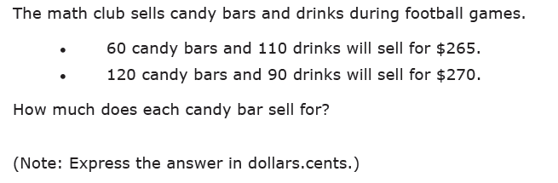11.

12. Given the volume of a rectangular prism is: $6x^{3}-21x^{2}-12x$. Find the dimensions.

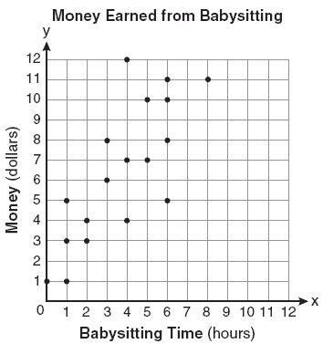**OBJ. 4: Calculator Inactive : Math I Unit 8 Study Guide**

13. Which of the following equations best models the (babysitting time, money earned) data?

14. Data was collected that described the weight of a male white laboratory rat for the first 25 weeks after its birth. A scatterplot of the rat’s weight (in grams) and the time since birth (in weeks) shows a fairly strong, positive linear relationship. The linear regression equation W=100+40t (where *W* = weight in grams and *t* = number of weeks since birth) models the data fairly well.

**What is the slope of the linear regression equation? Explain what it means in context**.

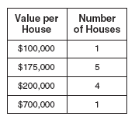

15. State which measure of central tendency, the mean or median best represents the data in the table to the right. Justify your answer using data from the table.

16. Delia wanted to find the best type of fertilizer for her tomato plants. She purchased three types of fertilizer and used each on a set of seedlings. After 10 days, she measured the heights (in cm) of each set of seedlings. The data she collected is shown below. **Which fertilizer do you recommend that Delia use? Explain your answer.**

|  |  |  |  |  |  |  |  |  |  |  |  |  |  |  |  |  |  |  |  |  |  |  |  |  |  |  |  |  |  |  |  |  |  |  |  |  |  |  |  |  |  |  |  |  |  |  |  |  |  |  |  |  |  |  |  |  |  |  |  |  |  |  |  |  |  |  |  |  |  |
| --- | --- | --- | --- | --- | --- | --- | --- | --- | --- | --- | --- | --- | --- | --- | --- | --- | --- | --- | --- | --- | --- | --- | --- | --- | --- | --- | --- | --- | --- | --- | --- | --- | --- | --- | --- | --- | --- | --- | --- | --- | --- | --- | --- | --- | --- | --- | --- | --- | --- | --- | --- | --- | --- | --- | --- | --- | --- | --- | --- | --- | --- | --- | --- | --- | --- | --- | --- | --- | --- |
| |  |  |  | | --- | --- | --- | | **Fertilizer A** | | | | 7.1 | 6.3 | 1.0 | | 5.0 | 4.5 | 5.2 | | 3.2 | 4.6 | 2.4 | | 5.5 | 3.8 | 1.5 | | 6.2 | 6.9 | 2.6 | | |  |  |  | | --- | --- | --- | | **Fertilizer B** | | | | 11.0 | 9.2 | 5.6 | | 8.4 | 7.2 | 12.1 | | 10.5 | 14.0 | 15.3 | | 6.3 | 8.7 | 11.3 | | 17.0 | 13.5 | 14.2 | | |  |  |  | | --- | --- | --- | | **Fertilizer C** | | | | 10.5 | 11.8 | 15.5 | | 14.7 | 11.0 | 10.8 | | 13.9 | 12.7 | 9.9 | | 10.3 | 10.1 | 15.8 | | 9.5 | 13.2 | 9.7 | |  |  |  |  |  |  |  | C:\Users\robertb.paulk\AppData\Roaming\Wabbitemu\\wabbitemu.gif |  |  |  |  |  |

Top Plot: Fertilizer A

Middle Plot: Fertilizer B

Bottom Plot: Fertilizer C