Foundations to Math 1 Unit 7 Study Guide

|  |  |  |
| --- | --- | --- |
| **1.** | | |
| **2.** | | |
| **3.** | | |
| **4.** | | |
| **4/4 = 100** | **3/4 = 80** | **0-2 = NY** |
| **5.** | | |
| **6.** | | |
| **7.** | | |
| **8.** | | |
| **4/4 = 100** | **3/4 = 80** | **0-2 = NY** |
| **9.** | | |
| **10.** | | |
| **11.** | | |
| **12.** | | |
| **4/4 = 100** | **3/4 = 80** | **0-2 = NY** |
| **13.** | | |
| **14.** | | |
| **15.** | | |
| **16.** | | |
| **4/4 = 100** | **3/4 = 80** | **0-2 = NY** |
| **17.** | | |
| **18.** | | |
| **19.** | | |
| **20.** | | |
| **4/4 = 100** | **3/4 = 80** | **0-2 = NY** |

Teacher:___________________________________ Student Name:______________________________

DIRECTIONS: Do all work on separate scratch paper. Your work must be neat, well organized, complete, and lead to the answer you give, circle your answers. Copy your answers to the appropriate place provide on this Study Guide.

|  |  |
| --- | --- |
| **Objective** | **Score** |
| 1 | A B NY |
| 2 | A B NY |
| 3 | A B NY |
| 4 | A B NY |
| 5  ANSWERS: | A B NY |

**OBJ. 1: Quadratic Structure**

**Use  to answer questions 1 and 2:**

1. What direction does the graph open and does it have a maximum or minimum?
2. What is the vertex of the function?
3. 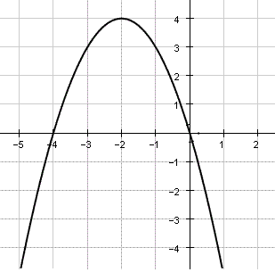How many zeros does the equation f(x) = x2 – 36 have?

4. Find the roots of the graph.

**OBJ. 2: Solving Quadratic Functions**

**Steps: 1. Set equal to zero ( = 0 ) 2. “X” method 3. Set each factor ( ) = 0 ( ) = 0**

1. 3x2 – 75 = 0 6. 6x2 – 7x = 20
2. 2x2 – 5 = 9x 8. 6x2 + 18x – 24 = 0

**Obj. 3: Review**

1. A movie club charges a one-time membership fee of $25 which allows members to purchase movies for $7 each. Another club does not charge a membership fee and sells movies for $12 each. How many movies must a member purchase for the costs of the two clubs to be the equal.? (Example: A movie club charges a membership fee of $100 which allows members to purchase movies for $5 each: 100 + 5x )

10. The perimeter of a rectangle is 50. The length is 4 times the width. Find the dimensions of the rectangle.

L Hint: Perimeter is add up all the sides.

W

1. The area of a trapezoid can be found using the formula . Write the expression that represents the area in *simplest* form. Hint: Plug *h* and *b1*. And *b2* into the formula.



*h* = 10

** (multiply) (=) (add)**

1. There are three consecutive **odd** integers. The product of the larger two integers is equivalent to the sum

of the first integer squared and 98. What are the integers? Hint: n, n + 2, n + 4 OR n, n+1, n+ 2

**OBJ. 5: Calculator Inactive Name______________________________**

1. Which of the following is the graph of the function *f* (*x*) = 2*x*2 + 3*x* + 4? (Circle one)

Hint: Find the y-intercept

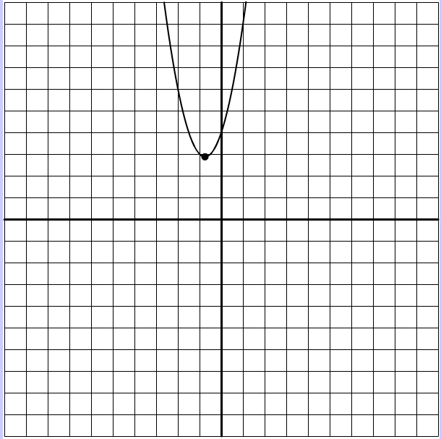A. B. C. D.

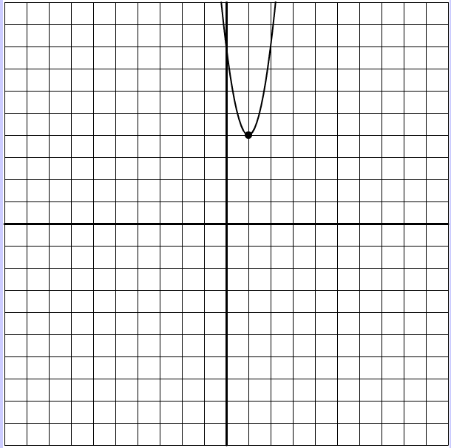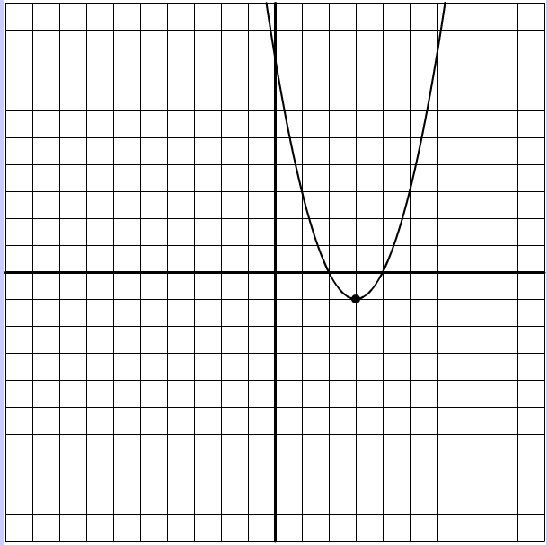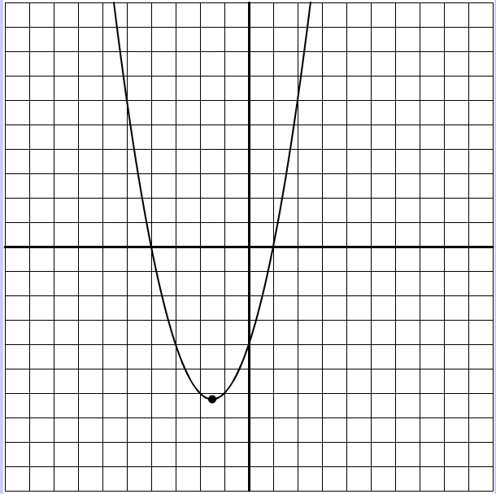

14. What is the y-intercept of h(t) = 6x – 3 + 9x2?

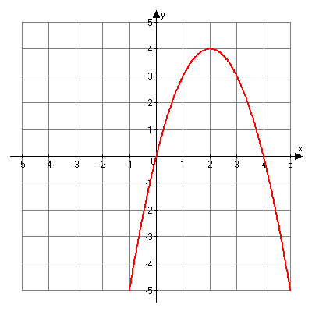15. What is the **maximum** of g(n) = – 4x2 – 8x + 37? Hint: Find the vertex. x = -b/2a plug in x to find y.

16.

|  |  |
| --- | --- |
| Opens | (Circle One)  Up or Down |
| y - intercept |  |
| Axis of Symmetry |  |
| Vertex |  |
| x-intercepts / roots / solutions / zeros |  |
| (Circle one)  Maximum or Minimum | Value of : |