Midterm Review Spring 2018 Name ____________________
- What is the inverse relation to the set of ordered pairs {(10, -5), (–2, 7), (0, 2), (8, –12)}?
- What are the increasing and decreasing intervals of the graph shown?
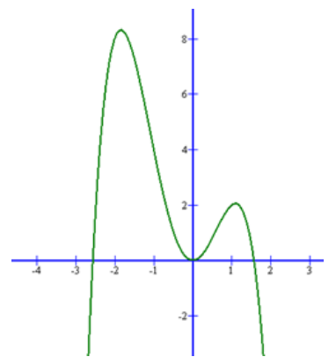

- Find the inverse function of .$f\left(x\right)=e^{x-3}$.
- If the function $f\left(x\right)=\left|x+2\right|-3$ is shifted up 2 units and right 5 units and flipped, what is the new function?
 | A | The value of f(x) will exceed the value of g(x) for all values of x.
 | B | The value of f(x) will exceed the value of g(x) for all values of x greater than or equal to 0.
 | C | The value of f(x) will never exceed the value of g(x).
 | D | The value of f(x) will exceed the value of g(x) for all values of x approximately between 1 and 2.
- Two functions are shown below.
$$f\left(x\right)=6^{x}+4 \\ g\left(x\right)=x^{6}-3x^{4}+2x^{2}+12$$
Which statement is true?

- Solve for x: $3^{x+2}={27}^{x}$
- Solve |2 + x| +4 < 18.
- Write the polynomial expression of least degree with the roots -3i and -2.
- Suppose Karen has $10,000 from investing in an account that pays 2.5% interest compounded quarterly at the end of 8 years. Approximately how much was her initial investment?

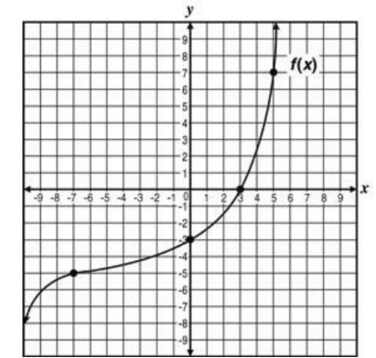
- The graph of the function, $f(x)$, is shown on the coordinate plane. Which value is closest to $f^{-1}\left(3\right)?$ ?

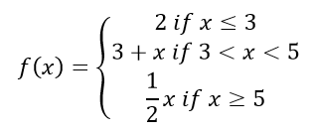
- Draw the graph is represented by the function.

- What is the range of $f\left(x\right)=3^{x}+2?$
- Given $k\left(x\right)=3x+2$ , find ${\left(k\left(x\right)\right)}^{2}$
- William and Sam each have $550 to invest. William’s investments earn a rate of 12%, and Sam’s investments earn a rate of 6.5%. Approximately, how much more money will William have than Sam when Sam’s investments are worth $820? (Assume continuous compounding, and round to the nearest hundredth of decimal.)
- Suppose $P\left(x\right)=x^{3}+2x^{2}-4x+k$. The remainder of the division of P(x) by (x + 1) is 1. What is the remainder of the division of P(x) by (x - 1)?
- Is the given binomial, (x + 1) a factor of $f\left(x\right)=x^{5}-3x^{3}+2?$
- Graph $y=\frac{1}{2}x+2$ and its inverse by hand.
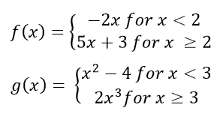
- Two piecewise functions are shown below.

What is the value of $-3f\left(2\right)+2g\left(1\right)?$
- Find the inverse function of $f\left(x\right)=\log\left(x-2\right)-5.$
- The expression $\left(x^{3}+4x^{2}-10\right)÷(x+3)$ can be written in the form $q\left(x\right)+\frac{r(x)}{b(x)}$ where $q\left(x\right)$ is the quotient, $r(x)$ is the remainder, and $b(x)$is the divisor. What expression is equivalent to $q(x)$?
- Solve: $\log_{x}{16=2}$
- Find the original function if $f^{-1}\left(x\right)=3\sqrt{x-2}$ .
- You work in the quality control department of a manufacturing company. The diameter of a drill bit must be between 0.83 inch and 0.85 inch. Write an absolute-value inequality to represent this requirement.
- The Drama Club is holding a car wash to raise money. The club spent $85 on materials and supplies. The club earns $10.25 for each car they wash. What is the inverse to the function of how much the club earns per cars washed?
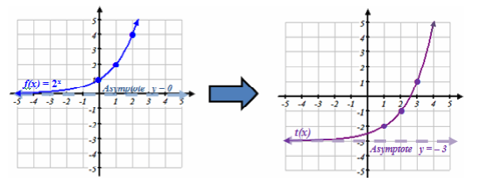
- Given $t(x)$ is a transformation of the graph $f\left(x\right)=2^{x}$, write the correct equation for $t(x)$?

- The volume of a box is given by the polynomial $\left(x\right)-x^{3}-12x^{2}-25x+30.$ What is the realistic domain?
- Find the remainder when $y=2x^{42}+2$ is divided by $(x+1)$.
- How long will it take $2000 to triple if it is invested in an account that pays 2% compounded continuously?
- Given $h\left(x\right)=x^{2}+3$ and $g\left(x\right)=5x-2$ Find $2h\left(x\right)-g\left(x\right).$
- Find all roots of the function $f\left(x\right)=x^{3}+2x^{2}-x+6.$

