Foundations Unit 8 Study Guide
We’re jamming, I wanna jam wid you, yeah we’re jamming, jammin…and I hope _________________________________likes jammin too.
Objective | Score
1 | A B NY
2 | A B NY
3 | A B NY
4 | A B NY
5 | A B NY
ANSWERS:
1.

2.

3.

4.

4/4 = 100 | 3/4 = 80 | 0-2 = NY
5.

6.

7.

8.

4/4 = 100 | 3/4 = 80 | 0-2 = NY
9.

10.

11.

12.

4/4 = 100 | 3/4 = 80 | 0-2 = NY
13.

14.

15.

16.

4/4 = 100 | 3/4 = 80 | 0-2 = NY
17.

18.

19.

20.

4/4 = 100 | 3/4 = 80 | 0-2 = NY

DIRECTIONS: Do all work on separate scratch paper. Your work must be neat, well organized, complete, and lead to the answer you give, circle your answers. Copy your answers to the appropriate place provide on this Study Guide.

OBJ. 1: Projectile Motion Application
1. The height of an object thrown into the air is given by the formula $h\left(t\right)= -4.9t^{2}+21t$, where h(t) is in meters and t is in seconds. What is the height of the object after 2 seconds? Just plug it in

Use the following for 2-3.
A ball is thrown into the air with an upward velocity of 64 ft/s. Its height, h, in feet after t seconds is given by the function .

2. How many seconds did it take for the ball to reach its maximum height AND what was the maximum height?
VERTEX so use x = -b/2a

3. When will the ball hit the ground?
Set = 0 and Solve

4. A rocket is launched into the air from a cliff that is 54 feet above the ocean. Its flight can be modeled by the equation . When will the rocket hit the water? Set = 0 and Solve

OBJ. 2: Solving Quadratics Application
Use the following for 5 & 6.
The observed bunny rabbit population on an island is given by the function, P(t) = -50t² + 700t + 6000 where t is the time in months since they began observing the rabbits.

5. What is the maximum population of bunnies?

6. After how many months does the bunny rabbit population reach 8000? (Yes, there are two answers!)

7. Solve for x.
x + 8
x + 7

x
8. If the measure of one side of a square is increased by 3 centimeters and the adjacent side is decreased by 3 centimeters, the area of the resulting rectangle is 40 square centimeters. Find the perimeter of the rectangle.

OBJ. 3: Review
9. Simplify: (2x³y²)⁻⁴ (3x⁵y²)²
Exponent rules to know: product rule, quotient rule, power to power, negative exponents

10. Solve: How to solve: Set = 0, then use the x method (slide divide bottoms up)

Multiply

11. Find the smallest of 3 consecutive even integers such that the product of the larger two is equivalent to the sum of the smallest integer squared and 50. (n, n+1, n+2 or n, n+2, n+4)
ADD

12. Find the area of the shaded region. Area of Shaded Region = Big Area – Small Area
Area = length * width
Big Area =____________________

Small Area = __________________

2x + 5
x – 1

x + 4

3x + 1

OBJ. 4: Calculator Inactive

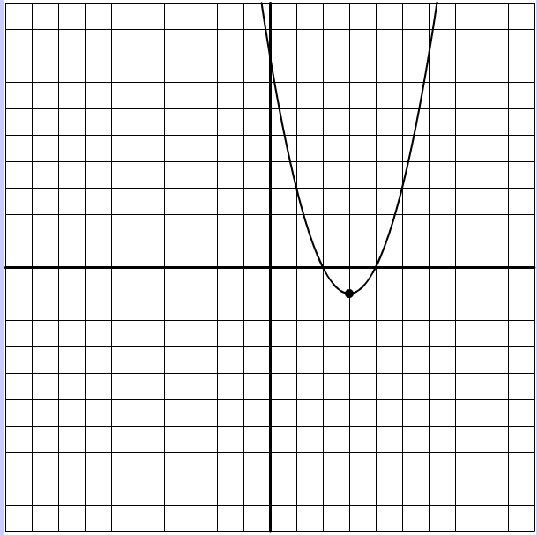
The parabola opens:  (Circle One) | Up or Down
y – intercept:
Axis of Symmetry:
What is the vertex:
x-intercepts / roots / solutions / zeros
Which does the parabola have?  (Circle one)  Maximum  Minimum | What is the value of the minimum or maximum?  ________________

- What is the smallest of 3 consecutive positive integers if the product of the smaller two integers is 5 less than 5 times the largest integer?

- What is/are the negative zeros of the function f(x) = x² – 9x – 36 ? Set = 0 and Solve

- The function h(t) = -6t² +56t + 85 models the approximate height of an object seconds after it is launched. What was the height of the object when it was launched? (Starting height)

