**Intensified Algebra Statistics Review**

**1.** The table below shows the population (in thousands) of North Carolina cities in the year 2000.

|  |  |
| --- | --- |
| **Name** | **Population (in thousands)** |
| Cary | 145 |
| Charlotte | 630 |
| Durham | 219 |
| Fayetteville | 317 |
| Greensboro | 275 |
| Raleigh | 399 |
| Wilmington | 203 |
| Winston-Salem | 125 |

Conover, NC had a population of about 25,000 in the year 2000. Which statement is true if Conover, NC is included in the data?

w/o NC w/ NC

1. The range decreases Mean: _____ _____
2. The interquartile range decreases Median: _____ _____
3. The standard deviation decreases Mode: _____ _____
4. The mean decreases Range: _____ _____

Standard Deviation: _____ ______

**2.** Nathan’s scores on the first five Math 1 tests of the year are shown below:

72, 64, 80, 75, 88

What would happen to the data distribution if Nathan scored 90, 76, and 84 on the next three tests?

1. The data distribution would become less peaked and more widely spread.
2. The data distribution would become less peaked and less widely spread.
3. The data distribution would become more peaked and less widely spread.
4. The data distribution would become more peaked and more widely spread.

**3.** A UPS driver is delivering packages. The truck he drives has a weight maximum of 8,000 pounds. To deliver all the packages, the driver needs to put 200 packages on the truck. He knows some measures from the data set of how much each packages weighed, and one package is much larger and heavier than the other 199. Which measure of central tendency would be most useful to determine if he can load all the packages safely?

1. mean
2. median
3. mode
4. standard deviation

**4.** The following table of data shows the salaries for each position at a technology company.

|  |  |
| --- | --- |
| **Position** | **Salary** |
| Company President (CEO) | $215,000 |
| Company Vice President | $168,000 |
| Data Analyst | $93,000 |
| Software Engineer | $89,000 |
| Marketing Director | $72,000 |
| Computer Technician | $60,000 |

If the company hired another computer technician who earned $60,000, which of the following statements ***not*** true about the data set if another data analyst is included?

1. The mean decreases
2. The median decreases
3. The range stays the same
4. The standard deviation increases

***Use the box and whisker plot below to answer questions #5 and 6.***

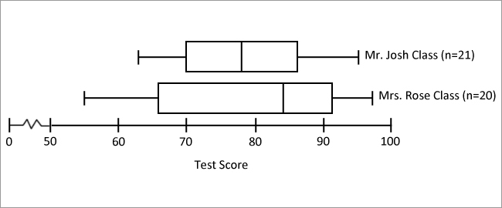

**5.** Which of the following is true about the test scores of classes shown above?

1. Mr. Josh’s class has a wider range of scores and the highest score compared to Mrs. Rose’s class.
2. Mr. Josh’s class a smaller range of scores and the highest score compared to Mrs. Rose’s class.
3. Mrs. Rose’s class has a wider range of scores and the highest score compared to Mr. Josh’s class.
4. Mrs. Rose’s class has a smaller range of scores and the lowest score compared to Mr. Josh’s class.

**6.** Which of the following statements are true about the classes.

1. Mrs. Rose’s class has a larger interquartile range, but a smaller median price than Mr. Josh’s class.
2. Mrs. Rose’s class has a larger interquartile range and larger median price than Mr. Josh’s class.
3. Mr. Josh’s class has a larger interquartile range than Mrs. Rose’s class.
4. Mr. Josh’s class has a larger median price than Mr. Rose’s.

**7.** The following box and whisker plots represent the number of miles ran by Ms. Nelson in April and May. What conclusion can be drawn from the box-and-whisker plot below?

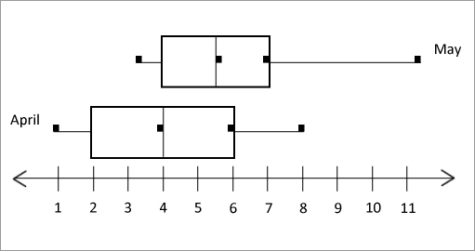

1. Ms. Nelson ran more miles in one run in April.
2. The Interquartile range of April is larger.
3. Ms. Nelson runs the same amount each month.
4. There is no conclusion that can be drawn from this data.

**8.** Which statement is true about the two box and whisker plots below:

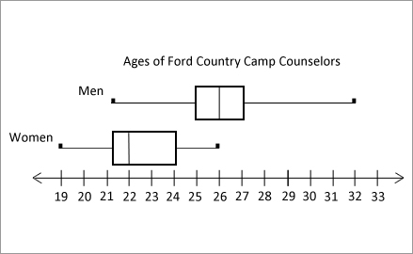

1. Half of the ages of the female counselors are between 20 and 24.
2. 25% of the male counselors are 27 or older.
3. The medians are the same for genders.
4. 50% of the female counselors are 23 or older.

**Use the following table for questions #9 – 10.**The students in a class conducted a survey to find out how many students had videos games at home and how many students at computers at home. Their results are given in the table below.

|  |  |  |  |
| --- | --- | --- | --- |
|  | **Video Games** | **No Games Video** | **Total** |
| **Computer** |  | 9 | 20 |
| **No Computer** | 16 |  |  |
| **Total** |  | 18 | 45 |

**9.** How many students do not have video games at home?

**10.** Create a relative frequency tables for the Two-Way Table then answer the question below.

What is the relative frequency of the students who do not have either a computer or video games?

**11.** The table below is a two-way relative frequency table about three favorite cereals: Cinnamon Toast Crunch (CTC), Fruit Loops (FL), and Lucky Charms (LC). In a survey, 200 children were asked select their favorite cereal. Which of the following statements is true?

|  |  |  |  |  |
| --- | --- | --- | --- | --- |
|  | CTC | FL | LC | Total |
| Boys | .165 | .075 | .135 | .375 |
| Girls | .31 | .115 | .2 | .625 |
| Total | .475 | .19 | .335 | 1.0 |

1. Lucky Charms is the most preferred cereal
2. 34 more girls than boys prefer Cinnamon Toast Crunch
3. 13 fewer girls than boys prefer Lucky Charms
4. 29 fewer boys than girls prefer Cinnamon Toast Crunch

**12.** The table below is a two-way relative frequency table of favorite leisure activities of 50 adults, 30 females and 20 males. Which of the following statements is true?

+

1. 8 more women prefer TV than men
2. 4 more men prefer sports than women
3. Sports is the most preferred leisure activity
4. 16 women prefer sports

**For questions 13 and 14 use the information below:**

James randomly surveyed 500 students at his high school to see what they thought of a possible change to the dress code. The results of the survey are shown in the relatively frequency table below.

|  |  |  |  |
| --- | --- | --- | --- |
| **Grade** | **In Favor** | **Opposed** | **Undecided** |
| **Freshman** | .21 | .02 | .01 |
| **Sophomore** | .15 | .01 | .02 |
| **Juniors** | .32 | .08 | .01 |
| **Seniors** | .12 | .04 | .01 |

**13.** How many more sophomores than seniors were included in the survey?

1. 14 **C.** 5
2. 3 **D.** 17

**14.** Which statement is true?

1. 6 more freshmen are in favor of lengthening the school day than sophomores
2. 44 juniors are opposed to changing the dress code
3. 25 students are undecided
4. 95 more sophomores are in favor of changing the dress code than those opposed