Foundations of Math 1 Unit 5 Study Guide

Teacher:__________________________ Student Name:______________________________

DIRECTIONS: Do all work on separate scratch paper. Your work must be neat, well organized, complete, and lead to the answer you give, circle your answers. Copy your answers to the appropriate place provide on this test.

|  |  |
| --- | --- |
| **Objective** | **Score** |
| 1 | A B NY |
| 2 | A B NY |
| 3 | A B NY |
| 4 | A B NY |
| 5 | A B NY |

ANSWERS:

|  |  |  |
| --- | --- | --- |
| **1.** | | |
| **2.** | | |
| **3.** | | |
| **4.** | | |
| **4/4 = 100** | **3/4 = 80** | **0-2 = NY** |
| **5.** | | |
| **6.** | | |
| **7.** | | |
| **8.** | | |
| **4/4 = 100** | **3/4 = 80** | **0-2 = NY** |
| **9.** | | |
| **10.** | | |
| **11.** | | |
| **12.** | | |
| **4/4 = 100** | **3/4 = 80** | **0-2 = NY** |
| **13.** | | |
| **14.** | | |
| **15.** | | |
| **16.** | | |
| **4/4 = 100** | **3/4 = 80** | **0-2 = NY** |
| **17.** | | |
| **18.** | | |
| **19.** | | |
| **20.** | | |
| **4/4 = 100** | **3/4 = 80** | **0-2 = NY** |

**OBJ. 1: Multiplying Polynomials**



2. 

1. 

**OBJ. 2: Multiplying Polynomials**

**5.** 

**6.** 

**7. ${(x-3)}^{2}$**

**8. $(2x-1)(3x^{2}+4x-1)$**

**OBJ. 3: Application**

**9.** The area of a triangle can be found using the formula A = ½ bh. If the height of the triangle is x and the base is 2*x* + 4. Find the simplified expression for the area of the triangle.

2x-1

10. Find the simplified expression for the

volume of the cube at the right.

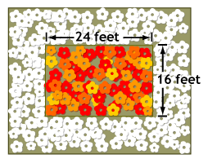11. The Lush Landscaping Company is involved in a project for the city. They will be enlarging the garden in front of City Hall. The current dimensions of the garden are 5 feet long by 10 feet wide. The company plans to make the garden area larger by planting a border of flowers all the way around the existing garden. The border will have the same width around the entire garden. Let x represent the width of the border. Write a polynomial expression that represents the area of the border.

**5 feet**

**10 feet**

12. There are three consecutive odd integers. The product of the larger two integers is equivalent to the sum of the first integer squared and 98. What are the integers?

**OBJ. 4: Review**

| X | Y |
| --- | --- |
| 5 | 11 |
| 9 | 8 |
| 13 | 5 |
| 17 | 2 |
| 121 | -1 |

13. Write the equation of the line that is **PERPENDICULAR** to the table to the right 🡪 🡪

and has the same y- intercept as 3x – 7y = 35.

14. Carla’s lemonade stand can sell at most 50 cups of lemonade in a day. Her daily profit is modeled by P(c) = 0.75c – 8.75 where profit, p, is a function of cups, c. What is the reasonable domain for the context of this problem?

Domain: talks about ____________ Least amount________ to highest amount ____________

_____< ___<_____

Range: talks about _________ Lleast amount_______ to highest amount _____________

_____<____<_____

**15. Simplify:**

**16**.  Solve the following equation for x: $y=\frac{1}{3}x(z_{1}+z_{2})$

**OBJ. 5: Calculator Inactive**

17. The area of a trapezoid can be found using the formula , where *A* is the area, *h* is the height, and *b1* and *b2* are the lengths of the bases. What is the area of the trapezoid below as an expression in *simplest* form?

*b*1 = 8*x* +3

*h* = 8

*b*2 = 2*x*– 7

**18.** If the perimeter of the triangle is, 6 $x^{2}+8x+10,$ what is the polynomial that represents the missing side length?

**19.** Write a simplified expression for the area of the rectangle.

6*x*2

4*x*2 – 3*x* – 7

3x2+2x+11

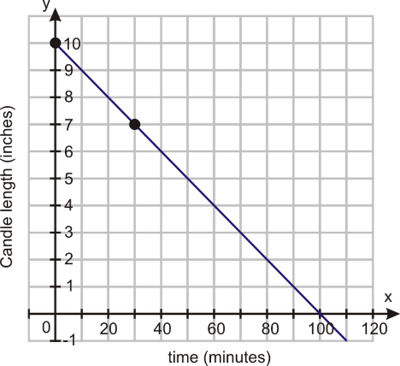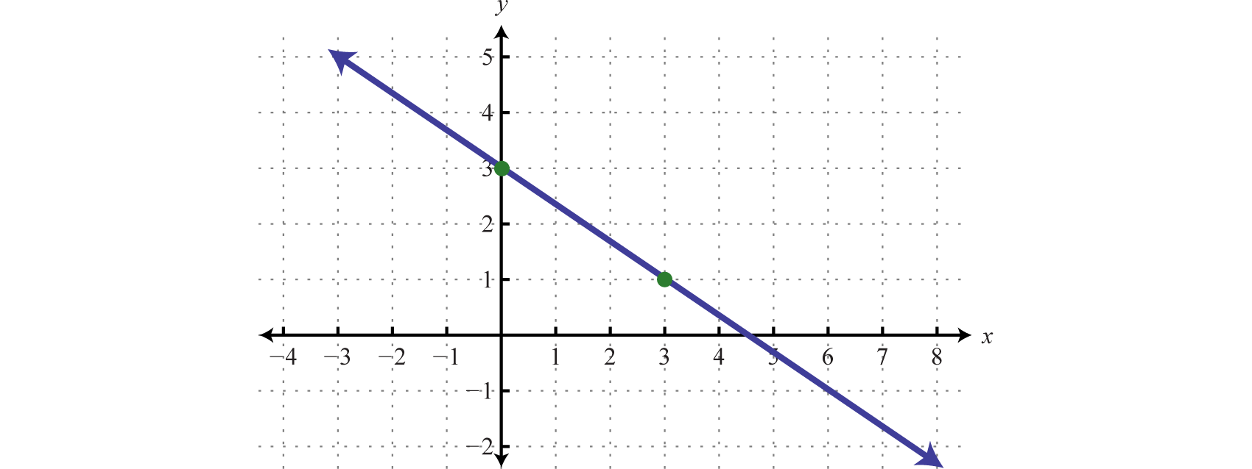**20.** What is the **product** of the **y**-**intercepts** of the line on the graph and the equation 15x – 6y = 24.