Characteristics of Functions:  Domain: all of the x-values of a function. Start with the lowest value. Bracket is for a number included in the domain.  Range: All of the y-values of a function. Start with the lowest value. Bracket is for a number included in the range.  End Behavior: What the graph is doing on the ends.  As x -> -∞, y -> __ means on the left side of the graph what is y approaching  As x -> ∞, y -> __ means on the right side of the graph what is y approaching  (can be a value, but if it goes up or down without a limit it will be ∞ or -∞).  Increasing, decreasing, and constant intervals: During which intervals (x-values) is the graph going upward? Downward? Staying the same? Always read from left to right. | Give the domain, range, end behavior, maxima, minima, and intervals of increase and decrease of the graph shown. (assume a scale of 1)  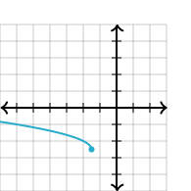  D: [-∞,-1.5) R: [-2.5, ∞)  EB: As x -> -∞, y -> ∞  As x -> -1.5 , y -> -2.5  No actual maximum or minimum, but the minimum output is -2.5. (not a minimum because there is not point on the right of it)  Int of increase: none  Interval of decrease: [-∞,-1.5)  Constant interval: none | Give the domain, range, end behavior, maxima, minima, and intervals of increase and decrease of the graph shown. (assume x and y axis use the same scale)  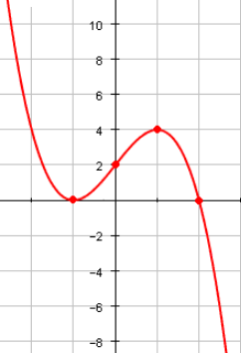
$$af\left(x-h\right)+k$$  If a is negative, the graph is flipped.  If |a|>1, the graph is vertically stretched (narrower)  If |a|<1 the graph is vertically compressed (wider)  In your equation, if a number is subtracted from x, the graph is shifted right that amount.  In your equation if a number is added to x, the graph is shifted left that amount.  If a number is added to the function, the graph is shifted up that amount.  If a number is subtracted from the function, the graph is shifted down that amount. | 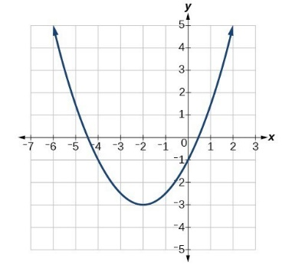  1. Write the equation for :  $$y=\frac{1}{2}{\left(x+2\right)}^{2}-3$$  2. If that equation were flipped, compressed by 4 and shifted right 5, what would be the resulting equation?  $$y=\frac{1}{2}{\left(x+2\right)}^{2}-3$$  Flipped makes it negative. To compress by 4, multiply by ¼. Right 5 is -5 from x.  $$y=-\frac{1}{8}{\left(x-3\right)}^{2}-3$$ | Write an equation for 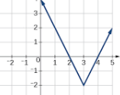  Equation: f(x) =  If g(x) is f(x) flipped, stretched by a factor of two, and shifted up 5, write a function for g(x).  Equation: g(x) =  Which function has a greater y-intercept?  Which function is wider?
Absolute Value and Piecewise  When solving absolute values, isolate the absolute value. Then make two equations to drop the absolute value bars, one negative and one positive. Once you have your solutions, check to make sure neither are extraneous.  For tolerance word problems,  $$|x-a|≤t$$  Where  a is the average or desired amount  t is the tolerance | Solve: $$-8x=2\left|x-3\right|+4$$  $$-8x=2\left|x-3\right|+4$$  $$-4 -4$$  $$-8x-4=2\left|x-3\right|$$  $$÷2 ÷2 ÷2$$  $$-4x-2=\left|x-3\right|$$  $$-4x-2=x-3$$  -x +2 -x +2  $$-5x=-1$$  X = 1/5  and  $$4x+2=x-3$$  -x -2 -x -2  $$3x=-5$$  X=-5/3  Now Check  $$-8(\frac{1}{5})=2\left|(\frac{1}{5})-3\right|+4$$  $$-\frac{8}{5}=2(\frac{14}{3})+4$$  $$-\frac{8}{5}=\frac{40}{3}$$  Extraneous  $$-8(-\frac{5}{3})=2\left|(-\frac{5}{3})-3\right|+4$$  40/3 = 2(14/3)+4  $$\frac{40}{3}=\frac{40}{3}$$  X = -5/3 works! | |-6x|< 30  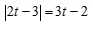  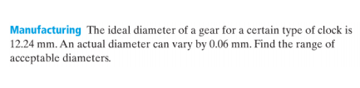
Piecewise functionsare functions that behave differently depending on the domain.  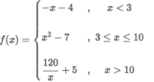  For the aboce, use the linear function y= –x-4 when x is less than 3.  You use the quadratic function y= x²-7 when x is between 3 and 10  Use the rational function y= 120/x+5 when x is greater than 10.  For $<or>use an open circle$  Function operations  Simply do the operation suggested by the problem. If they give you a number to evaluate, evaluate first. For composition of function (f(g(x)), start on the inside and work out. | Graph  $$f\left(x\right)= \left\{\begin{aligned}-x+2 , x<1 \\ x^{2} , x≥1\end{aligned}\right.$$  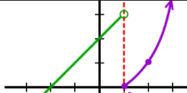  For the function above, evaluate  -3f(2)+f(-5)  $-3\left(2^{2}\right)+-\left(-5\right)+2$)  $$-3\left(4\right)+5+2$$  $$-12+7$$  -5  $$f\left(x\right)= x^{2} g\left(x\right)= -3x+1$$  Find (f+g)(-2)  $$g\left(-2\right)= -3\left(-2\right)+1=6+1=7$$  $$f\left(-2\right)= {(-2)}^{2}=4$$  7 + 4 = 11  Find $(f×g)(x)$  $$x^{2}\left(-3x+1\right)= -3x^{3}+x^{2}$$ | Graph: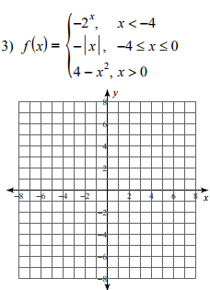  Then evaluate f(-2) +5(f(3))  $$f\left(x\right)= 3x^{2} g\left(x\right)=|x-5|$$  Find $(f×g)(3)$  Find $(f-g)(x)$
Inverses: The key concept of an inverse is the switching of x and y.  Graphically, we reflect over the line y=x.  In a table (or set of points), we switch the x and y values.  Algebraically, we switch x and y and solve for the new y.  Remember these inverse pairs:  Addition and subtraction  Multiplication and division  Square and square root  Exponential and logarithmic  F inverse of x is written $f^{-1}(x)$ | EX 1: Find the inverse of $y={2(3}^{x-4})$  $$x={2(3}^{y-4}) ⇾ \frac{x}{2}=3^{y-4}$$  Write the corresponding log eq.  $$y-4=\log_{3}{\frac{x}{2} ⇾y=\log_{3}{\frac{x}{2} +4 }}$$  Two lines that are inverses. Y=x is graphed to show they are reflected about it.  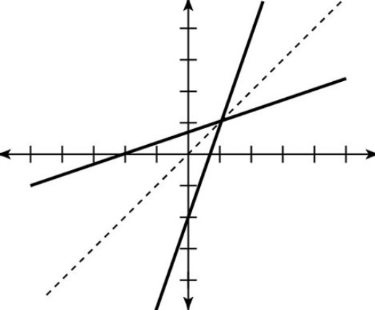 | 1. Find the inverse: $y=\sqrt{3x-4}+8$  2. Name two points that would be included in the inverse of the original function includes the points (3,1), (-2,5), and (0,-8)  3. Find the inverse of y = LN(2x-1)
Logarithms: Logs are used to solve for unknown exponents.  If $a=b^{x}$ then $\log_{b}{a}=x$  Change of base formula  $$\log_{b}{a}= \frac{\log{a}}{\log{b}}$$  $$\log{x}= \log_{10}{x}$$  $$\ln{x}=\log_{e}{x}$$ | Ex. 1) $3^{2x}=9$  $$\log_{3}{9}=2x$$  $$2=2x$$  $$x=1$$  Ex. 2) ${3e}^{x}-4=2$  get the power by itself (+4)  ${3e}^{x}=6$ divide by 3  $e^{x}=2$ put into log form  $\log_{e}{2}=x$ rewrite $\log_{e}{2}as\ln{2}$  $\ln{2}=x$ find ln2  .69 = x | 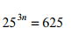  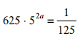  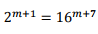
Exponentials:  Growth/Decay $A=P{(1+r)}^{t}$  Compounded Interest  $A=P{(1+\frac{r}{n})}^{nt}$  Interest Continuously Compounded  $$A=Pe^{rt}$$  A= Final amount  P = Starting amount (principle)  R = rate  T = time  N = Number of times compounded per period  Quarterly: n=4  Monthly: n = 12  Weekly: n = 52  Daily: n = 365 | The population of rabbits can be modeled by the equation $P=1304{(1.57)}^{t}$ Is the population increasing or decreasing? By how much?  The population is going up 57% because it is .57 greater than 1.  How long would it take $2000 to double in an account at 4% compounded continuously?  $${A=Pe}^{rt}$$  $${4000=2000e}^{.04t}$$  $${2=e}^{.04t}$$  $$\ln{2}=.04t$$  $$.69=.04t$$  17.25 = t  17.25 years | How long would it take $1500 to triple in an account that is compounded monthly at 7%?  How much money would you have if you had $10000 compounded continuously at 4% for 5 years?  The population of eagles in the united states can be modeled by$P=1304{(.85)}^{t}$

