I. Function Characteristics  Domain: Interval of possible x values for a given function. (Left,Right) or as an inequality  Range: Interval of possible y values for a given function. (down, up) or as an inequality  End Behavior: What is happening at the far ends of the graph?  For each side Left side Right side  $$x→-∞,$$ $$x→∞$$  Pick one of these Points Down Points Up  $$y→-∞$$ $$y→∞$$  Increasing Intervals: Interval of x values for which the corresponding y values are increasing.  Decreasing Intervals: Interval of x values for which the corresponding y values are decreasing.  x-Intercepts/roots/zeroes: points where the graph crosses the x axis. $(x,0)$  y-Intercepts: points where the graph crosses the y axis. $(0,y)$  Maximums: points where the graph changes from increasing to decreasing. Peaks in the graph.  Minimums: points where the graph changes from decreasing to increasing. Valleys in the graph. | 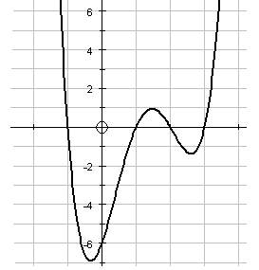 | Domain: $\left(-∞,∞\right)$  Range: $[-7,∞)$  End Behavior:  As $x→-∞, y→∞$As $x→∞, y→∞$  Increasing Intervals:  $$\left(-0.5, 1.5\right), (2.5, ∞)$$  Decreasing Intervals:  $$\left(-∞,-0.5\right),(1.5,2.5)$$  x-Intercepts: $\left(-1,0\right), \left(1,0\right), \left(2,0\right), (3,0)$  y-Intercepts: $(0,-6)$  Maximums: $(1.5,1)$  Minimums: $\left(-0.5,-7\right),(2.5,-1.25)$
 | 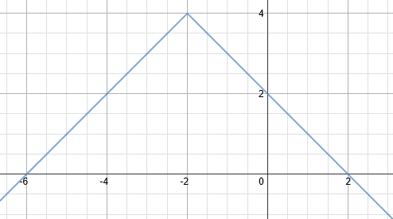 | Domain:  Range:  End Behavior:  As $x→-∞,$As $x→∞,$  Increasing Intervals:  Decreasing Intervals:  x-Intercepts:  y-Intercepts:  Maximums:  Minimums:
 | 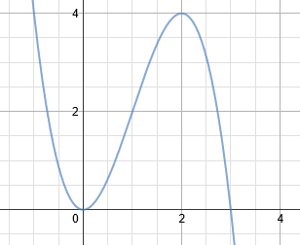 | Domain:  Range:  End Behavior:  As $x→-∞,$As $x→∞,$  Increasing Intervals:  Decreasing Intervals:  x-Intercepts:  y-Intercepts:  Maximums:  Minimums:

II. Function Transformations  General form: $g\left(x\right)=a f\left(x-h\right)+k$  f(x) parent function  g(x) transformed function  a if negative, flip vertically  0 < |a| < 1 vertical compression  |a| > 1 vertical stretch  h if negative, horizontal shift right  if positive, horizontal shift left  k if negative, vertical shift down  if positive, vertical shift up  Examples  $$E1. g\left(x\right)=x^{2}+2$$  Parent Function:  quadratic  Transformations:  shift up 2 units |  | $$E2. g\left(x\right)={-(x-4)}^{3}-1$$  Parent Function:  cubic  Transformations:  flip vertically  shift right 4 units  shift down 1 unit  $$E3. g\left(x\right)=3\sqrt{x+1}-7$$  Parent Function:  Radical (square root)  Transformations:  Stretch by a factor of 3  Shift left 1 unit  Shift down 7 units  $$E4. g\left(x\right)=-\frac{1}{2}{(x-3)}^{2}+1$$  Parent Function:  quadratic  Transformations:  Flip vertically  Compression by a factor of $\frac{1}{2}$  Shift Right 3 units  Shift up 1 unit |  |  | 1. $g\left(x\right)=2^{x-3}+5$  Parent Function:  Transformations:  2. $g\left(x\right)=-{(x+7)}^{2}$  Parent Function:  Transformations:  3. $g\left(x\right)=2\log\left(x-2\right)-1$  Parent Function:  Transformations:
III.Graphing a function from an equation - Example  1. Identify the parent function to determine a general shape.  Cubic  2. Think about where the vertex or critical points are usually found for the parent function.  Centered at the origin. Is always increasing from left to right.  3. Where are the critical points of the new function given the transformations in the equation? Since there is a horizontal shift right 1 unit and a vertical shift down four units, the center is at the point (1,-4).  4. Use this information to plan which points to plot on the graph. Make a t table with these points.  Since the center of the graph is (1,-4), pick two x values on either side of this point and evaluate the f(x) at those x’s. |  |  | Graph $f\left(x\right)=2{(x-1)}^{3}-4$  x y 5. Plot the points and connect the dots.  -1 -20  0 -6  1 -4  2 -2  3 12
Graphing a function from an equation  1. Identify the parent function to determine a general shape.  2. Think about where the vertex or critical points are usually found for the parent function.  3. Where are the critical points of the new function given the transformations in the equation?  4. Use this information to plan which points to plot on the graph. Make a t table with these points. |  |  | Graph $f\left(x\right)=-{\left(x+3\right)}^{3}+6$  x y 5. Plot the points and connect the dots.
Writing Function Equation from a description of the transformations  How do translations effect equation?  $$f\left(x\right)=-a\left(x-h\right)+k$$  “-“ flip over x axis  a compression or stretch  h horizontal shift in the opposite direction of the sign  k vertical shift in the same direction of the sign  EXAMPLE  Write the equation for a quadratic function with a vertical shift down 3, left 7 and a vertical stretch by a factor of 4.  Quadratic : x²  Down 3: -3 from the function (outside)  Left 7: add 7 to x (inside)  V. stretch by 4: multiply by 4  $$y={4\left(x+7\right)}^{2}-3$$ | Write the equation for an absolute value function that has been compressed by a factor of 2 and shifted down three units  Write the equation for a cubic that has been flipped vertically, shifted up 5 units, and shifted right 2 units.
Determining Equation from Graph  What’s the parent function?  Where’s the vertex or critical point of the parent function?  Where’s the vertex or critical point of this function?  How did we get from the parent function critical point to the critical point of this function?  How do I translate those changes into an equation? | Example: Write the equation for the following graph.  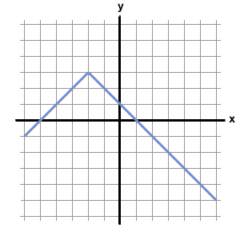  Cubic so x³ vertex is up 2, right 1  $$y={(x-2)}^{3}+1$$ |  |  | Write the equation for the following graph
Shifts of Shifts  Apply the stated changes to the appropriate parts of the “starting function”. | Example: If the function $f\left(x\right)={(x+1)}^{2}-1$, what would be the equation of g(x) if g(x) is f(x) shifted left 3 units, up 2 units, flipped vertically and stretched by a factor of 4?  Left 3: +3 to x Up 2: + 2  Flipped vertically: - in front  Stretched by 4: multiplied by 4  $$g\left(x\right)=-4{(x+1+3)}^{2}-1+2$$  $$g\left(x\right)={-4(x+4)}^{2}+1$$ |  |  | $$f\left(x\right)={2(x)}^{3}+4$$  Find g(x) if g(x) is f(x) shifted up 2, right 1 and compressed by a factor of 6.  $$f\left(x\right)=-\left|x-5\right|$$  Find g(x) if g(x) is f(x) shifted up 4, left 3, stretched by a factor of 2, and flipped vertically.
Shifts of Shifts part 2  State the transformations to f(x) that would yield g(x)  Example: $f\left(x\right)=-3\sqrt{x-4}+1$  $g\left(x\right)=\frac{3}{5}\sqrt{x+4}+7$  Was +1, now is +7 so went up 6  Was -4 now is +4 so went left 8  Was 3 now 3/5 so compressed by a factor of 5  Was negative, now positive so flipped vertically | $$f\left(x\right)=\left|x+2\right|-3$$  $g\left(x\right)=-2|x+1|+2$ |  |  | $$f\left(x\right)={-3(x-1)}^{2}-3$$  $g\left(x\right)=-{(x+4)}^{2}-5$

Function Notation and Function Operations  Function notation uses f(x) instead of y. Plug in whatever number is in the parentheses for x.  Ex. f(x) = 8x+2.  Find f(3)  f(3) = 8(3)+2 = 24 + 2 = 26  Function operations can be indicated like so (f-g)(x) would mean subtract g(x) from f (x). Similarly, (f∙g)(2) would mean find the product of f(2) and g(2) | $$f\left(x\right)=2x-3$$  $g\left(x\right)=-2x^{2}$  Find f(3)  $$f\left(3\right)=2(3)-3$$  $$f\left(3\right)=6-3$$  $$f\left(3\right)=3$$  Find f(2) – 2g(1)  $$f\left(2\right)=2\left(2\right)-3$$  $$f\left(2\right)=4-3$$  $$f\left(2\right)=1$$  $$g\left(1\right)=-2{(1)}^{2}$$  $$g\left(1\right)=-2(1)$$  $$g\left(1\right)=-2$$  f(2) – 2g(1)  1 – 2(-2)  1+4  5  Find (f∙g)(2)  $$f\left(2\right)=2\left(2\right)-3$$  $$f\left(2\right)=4-3$$  $$f\left(2\right)=1$$  $$g\left(2\right)=-2{(2)}^{2}$$  $$g\left(2\right)=-2(4)$$  $$g\left(2\right)=-8$$ | $$f\left(x\right)={-3x}^{2}$$  $g\left(x\right)=x^{2}-1$  Find f(-2)  Find 2g(3)+f(-1)  Find (g-f)(x)  Find (g+f)(1)  (f∙g)(-3)
Piecewise Functions  Piecewise Functions behave differently based on the input.  For instance, $f\left(x\right)=\left\{\begin{aligned}3x , x<3 \\ x+2 , x≥3\end{aligned}\right.$  If the input, x, is less than three, use 3x. If it is greater than three, use x+2.  So,  f(4) = 4+2 = 6  f(1) = 3(1) = 3 | $$f\left(x\right)= \left\{\begin{aligned}x^{2} , x<1 \\ 2x+3, x≥1\end{aligned}\right.$$  Find f(0)  Find f(1)  Find f(2) | $$f\left(x\right)=\left\{\begin{aligned}-x , x≤0 \\ 2 , 0<x<2 \\ 2x , x≥2\end{aligned}\right.$$  Find f(3)  Find f(-5)  Findf(1.5)  Find f(2) – f(5) + 3f(-6)  Find f(-1)+f(0)-f(1)+½f(2)
Graphing Piecewise Functions  Graph each section of the graph for and only for its corresponding domain.  So the graph of $$f\left(x\right)= \left\{\begin{aligned}1 , x<-1 \\ x^{2}-3 , x≥-1\end{aligned}\right.$$  Would be:  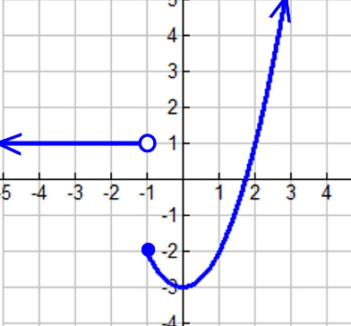 | $$f\left(x\right)= \left\{\begin{aligned}x^{2} , x<1 \\ 2x+3, x≥1\end{aligned}\right.$$  Graph | $$f\left(x\right)=\left\{\begin{aligned}-x , x≤0 \\ 2 , 0<x<2 \\ 2x , x≥2\end{aligned}\right.$$  Graph
Absolute Value  Equations and Inequalities  To solve absolute value equations or inequalities:  1. isolate the absolute value  2. drop the bars to create two equations. Change all signs on one side of the second equation.  3. Solve both equations  4. Plug in your answers to the original to check for extraneous solutions.  * For inequalities, don’t forget that flipping the signs results in the flipping of the inequality as well.  Tolerance:  $$\left|x-a\right|≤t$$  Where a is the desired amount or the average and t is the tolerance. | $$\left|x-2\right|+4=2x+7$$  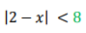 | An iPhone seven is supposed to weigh 192 grams, but it is allowed a margine of error of up to .4 grams. Write an absolute value inequality to represent this.  The ideal weight for a DDR player is 160 pounds, but the game will still perform near optimally for anyone within 85 pounds of that. Write an absolute value inequality to represent this. Solve it.

