STUDY GUIDE Name____________________________________________________ Date________ Period___
Equation of a circle:  $${\left(x-h\right)}^{2}+{\left(y-k\right)}^{2}=r^{2}$$  Where (h,k) is the center and r is the radius.  Ex: Write an equation for a circle with a radius of 8 and a center at (3,-2)  Answer:  $${(x-3)}^{2}+{(y+2)}^{2}=64$$ | 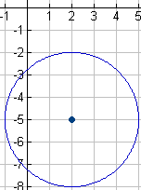  1. What is the equation of the circle to the right?  2. what are the center and the radius of the following circle:  ${(x+5)}^{2}+{(y+2)}^{2}=9$?
Completing the square: |  | Use completing the square to put the following equations of a circle in standard form:  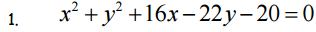  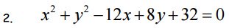
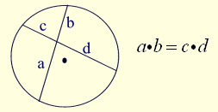 | 4x=3(8) simplify  4x=24 divide by 4  X=6 | 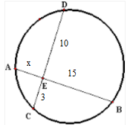  1.  2.
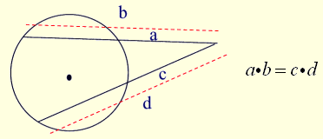  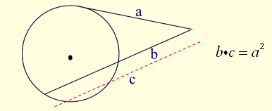  outside ∙ whole = outside ∙ whole | 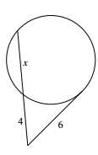  $4\left(x+4\right)=6\left(6\right)$ simplify  $4x+16=36$ subtract 16  $4x=20$ divide by 4  $x=5$1 | 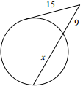  1.  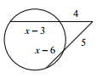  2.
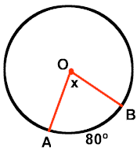  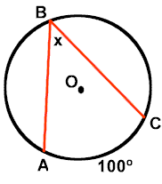  Central angle = intercepted arc Inscribed angle = ½ (intercepted arc)  X=80 X= 50 |  | 1. 2.  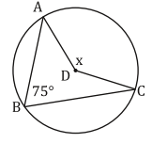
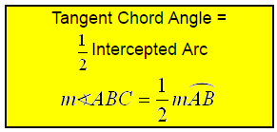  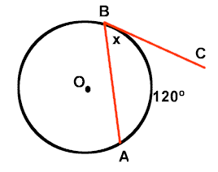  $$x=\frac{1}{2}\left(120\right) x=60$$ |  | 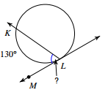  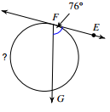
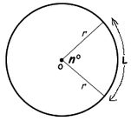  ARC LENGTH: $L=2πr(\frac{n^{o}}{{360}^{o}})$  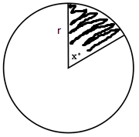  SECTOR AREA: $A= {πr}^{2}(\frac{x^{o}}{{360}^{o}})$ | 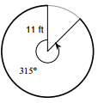  Find the arc length  $L=2π11(\frac{{315}^{o}}{{360}^{o}})$  L = 60.5 feet  Find the sector area  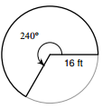  $$A= {π16}^{2}\left(\frac{{240}^{o}}{{360}^{o}}\right)$$  A = 536.2 | 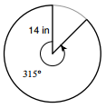  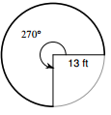  arc length:  Sector area:  You are eating a doughnut. The missing circle in the middle has a radius of 0.2 inches. The entire doughnut has a radius of two inches. Your first bite takes 70 degrees out of the circle. What is the remaining area of the doughnut?
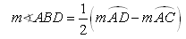  (big arc) – (small arc) = 2(angle)  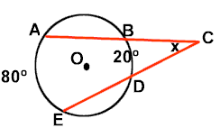  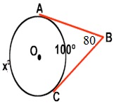  $x-100=2(80)$ simplify $80-20=2x$ simplify  $x-100=160$ add $60=2x$ divide  $x=260$ $x=30$  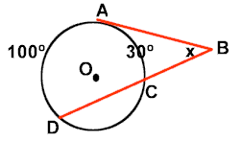  $100-30=2x$ simplify  $70=2x$ divide  $$x=35$$ |  | 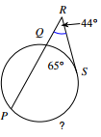  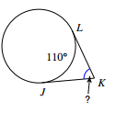  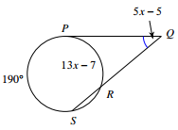
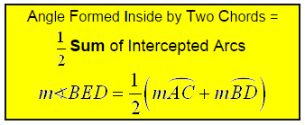  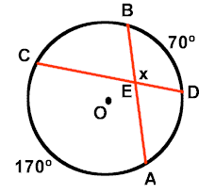  OR $arc+arc=angle+angle$  $170+70=x+x$ simplify  $240=2x$ divide  $$x=120$$ |  | 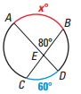  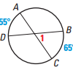
A circumscribed angles and their arcs are always supplementary.  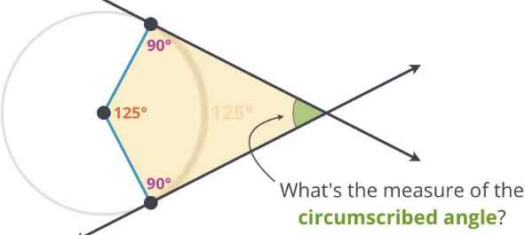  $x+125=180$ subtract  $$x=55$$ |  | 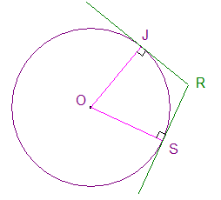  Find angle R if angle O is 70 degrees.

