Math 1 Unit 2 Study Guide

|  |  |
| --- | --- |
| **Objective** | **Score** |
| 1 | A B NY |
| 2 | A B NY |
| 3 | A B NY |
| 4 | A B NY |
| 5 | A B NY |

ANSWERS:

|  |  |  |
| --- | --- | --- |
| **1.** | | |
| **2.** | | |
| **3.** | | |
| **4.** | | |
| **4/4 = 100** | **3/4 = 80** | **0-2 = NY** |
| **5.** | | |
| **6.** | | |
| **7.** | | |
| **8.** | | |
| **4/4 = 100** | **3/4 = 80** | **0-2 = NY** |
| **9.** | | |
| **10.** | | |
| **11.** | | |
| **12.** | | |
| **4/4 = 100** | **3/4 = 80** | **0-2 = NY** |
| **13.** | | |
| **14.** | | |
| **15.** | | |
| **16.** | | |
| **4/4 = 100** | **3/4 = 80** | **0-2 = NY** |
| **17.** | | |
| **18.** | | |
| **19.**  **D=**    **R=** | | |
| **20.** | | |
| **4/4 = 100** | **3/4 = 80** | **0-2 = NY** |

Student Name: ___________________________________________

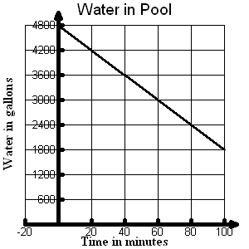**OBJ. 1: Writing Linear Functions**

1. Write a function that models the situation in the graph.

|  |  |
| --- | --- |
| w (wristbands) | D(w)  (dollars) |
| 0 | -60 |
| 5 | -30 |
| 10 | 0 |
| 15 | 30 |
| 20 | 60 |

2. Create a function that models the information in the table below.

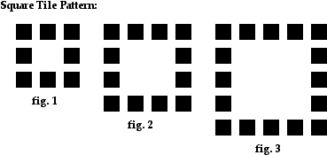

3. Ms. Morris gave the following pattern of squares to her class. Write an equation to represent the number of squares, s, for any figure number n.

4. A cell phone company charges a monthly fee of $55 and $0.05 per minute. Write a function that relates the total monthly charge, C(m), and the number of minutes, m, that a customer uses.

**OBJ. 2: Linear Interpretation**

1. The cost of a chicken dinner special is given by the linear relationship C(s) = 2.25s + 7.00 where c(s) is the cost of the dinner and s is the number of side items ordered. What does the **rate of change** for the function represent?

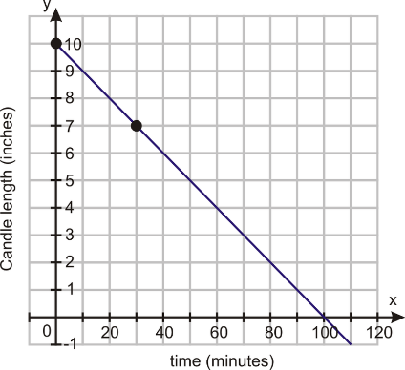

1. What does the **y- intercept** represent in the equation from problem 5?
2. What is the meaning of the **x-intercept** for the graph to the right?
3. What is the meaning of the **rate of change and the y- intercept** for the table below.

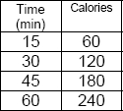 Rate of Change:

Y-intercept:

**OBJ. 3: Comparing Linear Functions**

9. Which function has a larger slope? State the slope.

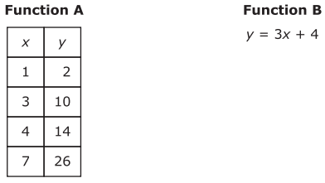

10. What is the difference of the y-intercepts of the Function C and f(x).

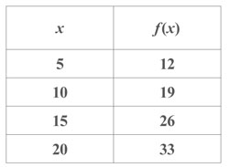

Function C: 12x – 5y = 25

11. What is the product of the slopes for the given functions f(x) and g(x).

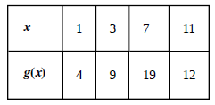

g(x) f(x)

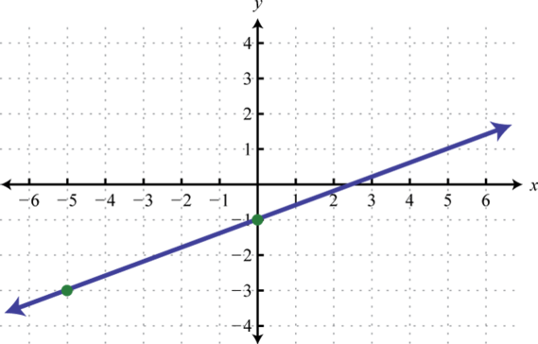

29

12. Find the sum of the y–intercepts for the graph of f(x) to the right

and 3y = 1/2x + 9.

**OBJ. 4:**

13.Write the equation for the line that is **PARALLEL** to 2x – 3y = 12, and passes through the point (9, -3).

14. Write the equation for the line that is **PARALLEL** to $y=-2x+3,$ and passes through the point (-5, 7).

15. Write the equation for the line that is **PERPENDICUALR** to $y=2x-4$ and passes through the point (-6, 4).

16. Write the equation of the line that is **PERPENDICULAR** to $4y=2x-8$ and has the same y- intercept as 3y = 2x – 6.

**OBJ. 5: Calculator Inactive**

17. Solve for r:

18. Find the largest of three consecutive odd integers such that 3 less than twice the first is four more than the middle integer.

19. Lou wants to sell candy at school to make a little bank. He borrowed $40 bucks from his sweet momma, whom he promises to pay back. He bought 150 candy bars and plans to sell them for $1.00 each. Write a reasonable domain and range for this scenario.

20. Create a graph of the line 4x + 3y = 12.

