Math 1: Unit 5 Hw Part 2 Name _______________________________
**************** Due: Monday November 20th, 2017 **************
Multiply each of the following.

- 9y²(5y – 3)
- 2.3z³(12z + 4z³ – 1)
- 2pq(3p² + 6pq + 7q²)
- -5xy³( -3x³ + 7y – 2xy)
- (3x + 2)(x + 4)
- (2x + 5y)(7y – 3x)
- (8r² – 2r)(5r + 4)
- (2n -7)(3n + 3)
- (4x + 9)(2x² – 5x + 3)
- (3x + 5)²

- Find the area of the shaded region. Show all work.
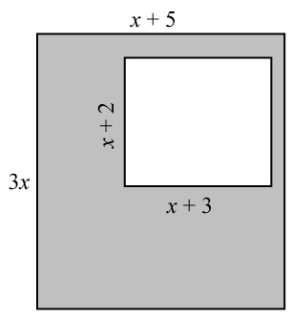
12.
The area of the rectangle is x² + 6x - 7. Find the perimeter of the rectangle.

14.
A rectangle has a length of 3x + 5 and a width of 2x – 3, find the area.

13. Find 3 consecutive, negative odd integers such that the larger squared plus 38 is the same as the product of the smaller two.

15. What is the volume of a rectangular prism with length of 3x +1, the height of x + 3 and the width of 2x – 3.

Factor the following(GCF)
16.

Factor the following
22. There are 3 consecutive odd integers. The product of the larger two integers is equivalent to the sum of the first integer squared and 146. What are the integers?

- 2n² + 15n + 7

23.
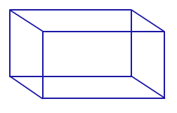
The volume of a rectangular prism is 2x³ + 6x² – 8x. Find the dimensions of the prism (length, width, height),

Review:

24. Simplify:

25. Solve: 6x – 3(x – 4) = x – 2

26. $\frac{{(2x^{2}y^{-3}z)}^{-2}}{{(3x^{-1}y^{2}z^{0})}^{2}}$
27. (4x² – 6x + 3) – (5x² – 12x – 3)
28. Solve for h: SA = 2πr² + 2πrh
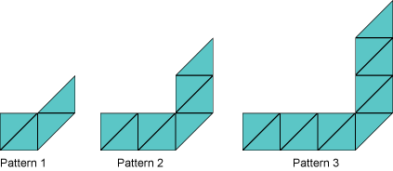
29. Ms. Hill gave the following pattern of triangles to her class. Write an equation to represent the number of triangles, t, for any figure number n.

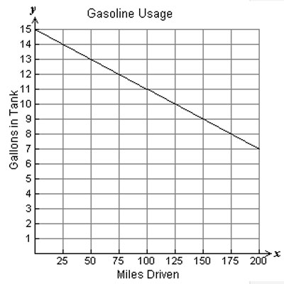
30. What is the meaning of the x-intercept for the
graph to the right?

31. Find the sum of the y-intercepts for the graph below and: $3y=9x-9$
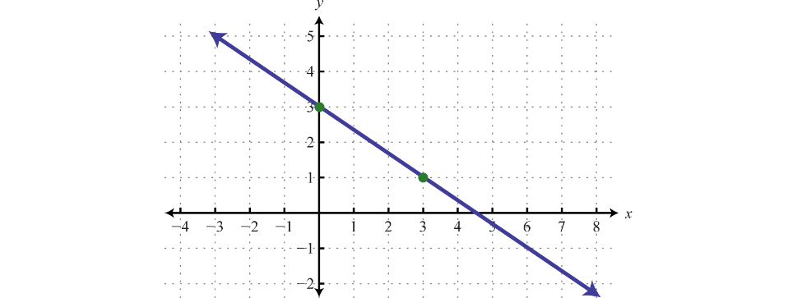
32. Solve using any method:
y = 2x + 5
3x – 4y = 10

- The math club sells hotdogs and drinks during football games.
- 100 hotdogs and 400 drinks will sell for $500
- 150 hotdogs and 200 drinks will sell for $450
How much does each hotdog sell for?

- Two different types of batteries are needed to run Joshua’s remote-controlled jeep. The two batteries produce a total voltage of 6.5 V. The difference in their voltage is 2.5 V. Determine the voltages of the two batteries.

- Sarah is selling bracelets and earrings to make money for summer vacation. The bracelets cost $2 and the earrings cost $3. She needs to make at least $60. Sarah knows she will sell more than 10 bracelets. Write inequalities to represent the income from jewelry sold and number of bracelets sold.

- The sum of four consecutive odd integers is 48. What is the largest integer?

