Math 1 Homework: Unit 6 Quadratics Name: _____________________________________
Due December 8, 2017

- What is the standard form of a quadratic equation?
- What determines a maximum or minimum point?
- What is the axis of symmetry?

- Write the axis of symmetry and the vertex of the following equations:
  - y = x²- 4
  - y = x²- 2x -4
  - y = -2x² – 4x + 6
  - y = -x²

- Solve each equation by factoring:
  - x² +x – 42 = 0
  - c² = 5 c
  - n² - 9n = -18
  - m² = 4m
  - 22x – x² = 96
  - 3x² +12x + 9 = 0
  - 4c² = 16

- Use the graphing calculator to solve the following:
  - 2x² -11x + 5 = 0
  - (x + 5)(x – 2)=0

- The expression h(t) = -6t² + 12t + 48 predicts the height h, in meters, of an object t seconds after a person launches it into the air. Using this expression, answer the following:
  - After how many seconds will it take the object to hit the ground?
  - After how many seconds does the object reach its maximum height?
  - What is the object’s maximum height?

- There are three consecutive positive integers such that the product of the smaller two is 34 less than 10 times the largest integer. What is the value of the smallest integer?

- There are three consecutive positive integers such that the product of the larger two integers is four more than twice the smallest integer. What is the value of the largest integer?

- The area of a triangle is 12 square meters. The height of the triangle is eight less than twice the base. What is the height of the triangle?

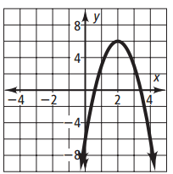
- Which graph represents the function y = 3x² + 12x – 6?

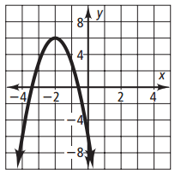
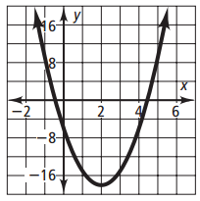

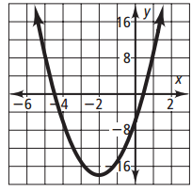

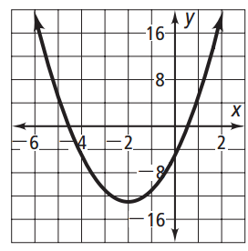
- Which equation matches the graph shown at the right?
  - y = 8x² + 2x – 5
  - y = 8x² + 2x + 5
  - y = 2x² + 8x – 5
  - y = 2x² + 8x + 5

Review Section:

MULTIPLYING POLYNOMIALS

Multiply each of the following.
- (4x-3)(2x + 6)
- (2x+1)²
- (3x + 2)(x² +4x-3)
- (2x + 5y)(6x-5y)
- 2(3x + 5)²+4

FACTORING POLYNOMIALS

FACTOR
- g² – 2g – 63
- y² + 4y – 60
- 2a² + 5a + 3
- 18x² – 27x – 5
- 3x² + 2x – 8
- 10x² – 19x – 15
- 4x² + 4x – 3
- 3a² + 30a + 63

AREA – FACTORING APPLICATION
- The area of a rectangle is g² + 7g +10, find the dimensions of the rectangle.
- The area of a square is m² + 12m + 36. Find the length of each side.
- Find the perimeter of the square in question #2.
- The volume of a rectangular prism is 8m³ – 32m. Find the length of all three sides. How many sides are binomials?
- The area of a rectangle is 8w² +2w – 15. If one of the sides is (4w – 5), what is the length of the other side?
MORE FACTORING APPLICATION
1. Find the middle of three consecutive integers such that the product of the smaller two plus 34 is equal to the largest integer squared.
2. Find three consecutive even integers such that the largest integer squared is the same as the product of the smaller two plus 88

Vocabulary:

Formulas:
Standard form: y = ax ² + bx + c
Axis of symmetry: x = - $b/ 2a$
Projectile motion: h(t) = -16t² +vt + c
Area: Rectangle A = lw
Triangle A = ½ bh

- Axis of symmetry
- Solutions
- Vertex
- X-intercepts
- zeros
- Roots
- Velocity
- Max/min
- Height
- Domain
- Range
- time and height

Graphing:
- If it is in standard form you can find AOS and vertex by using x = -b/2a

Solving:
- When solving a quadratic equation you always have to make the equations equal zero
- You can solve by 3 different methods- factoring (x-factor, gcf, difference of squares), quadratic formula, and graphing
- Remember the answers can be called “ solutions, roots, zeros and x – intercepts”

Projectile motion:
- The equation – 16t² +vt + c where t is the time, height is the height, and v is the velocity and c is the original height.
- If it asks for a maximum height, or the time to get to the that height then you are looking for the vertex ( use 2nd calc/ max method or the or axis of symmetry method)
- If you are looking for hitting the ground, graph on the calc by using 2nd calc intersect or factor for the positive solution
- If you are given a specific time and asked for a height , plug in the time for t and solve

Area Word Problems:
- Set up your equation based on the problem and equal it to zero
- Multiply by foil or distribute then factor, equal each factor to zero and solve
- Chose the positive answer and substitute into the given dimensions

Consecutive integer:
- The product of consecutive integers will give a quadratic equation. Example: n (n+1) = 56
- Equal the equation to zero and solve for the positive number or negative number depending on the question.
- Be careful for equations that can be complicated. Such as if the product of 2 consecutive integers is equal to 2 times the larger number increased by 4

