Centers of Triangles
Review | Example | Practice
- Centroid: Intersection of Medians  - Orthocenter: Intersection of Altitudes  - Incenter: Intersection of Angle bisectors  - Circumcenter: Intersection of perpendicular bisectors | 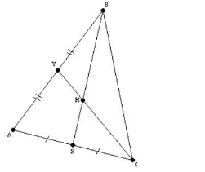  This is the centroid because the segments are medians.  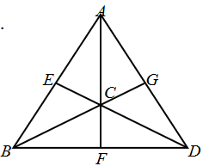  C is the centroid of the triangle.  If AC = 12, find the length of AF.  AC is twice the length of CF, so CF =12/2 = 6  Therefore, the length of AF is 12 + 6 = 18. | Identify the segments and the point of concurrency.  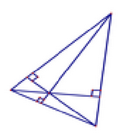  - Segment: ___________  Point: _____________  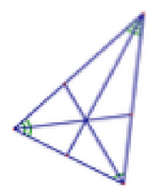  2. Segment: __________  Point: _____________  3. L is the centroid of the triangle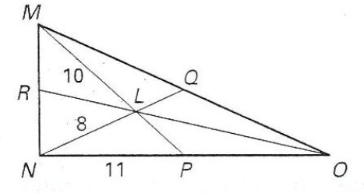  Find the lengths:  PO = ________ LQ = ________  MP = ________ NQ = ________
Parallelograms
Parallelograms:  - Opposite sides are parallel and congruent.  - Opposite angles are congruent.  - Consecutive angels are supplementary.  - Diagonals bisect each other. | The following shapes are parallelograms. Solve for the variables.  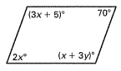  2x = 70 3x+5 = x+3y  x = 35 3(35)+5 = (35)+3y  110 = 35+3y  75 = 3y  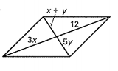  25 = y  3x = 12 x + y = 5y  x = 4 (4) + y = 5y  4 = 4y  1 = y | 1. The following shapes are parallelograms. Solve for the variables.  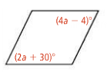  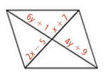  2.  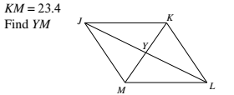
Volume
Know your area and volume formulas  -Prism  $$V=Bh$$  -Cylinder  $V=πr^{2}h$  -Pyramid  $V=\frac{1}{3}Bh$  -Cone  $V=\frac{1}{3}πr^{2}h$  -Sphere  $V=\frac{4}{3}πr^{3}$ | Class notes | 1. Two spheres M and N have volumes of 250 cubic cm and 750 cubic cm respectively. Find the ratio of their radii.  2. Two metal cubes with sides of 4 cm are melted and casted into a spherical ball. Find  the radius of sphere so formed.  3. A cone has a volume of 317π cm³ and a height of 5 cm. Find the diameter of the base.  4. You have been asked by your school to design a brick planter that will be used by classes to plant flowers. The planter will be built in the shape of a right rectangular prism with no bottom so water and roots can access the ground beneath. The exterior dimensions are to be $12 ft.$ $×$ $9 ft.$ $×2\frac{1}{2} ft$. The bricks used to construct the planter are $6 in.$ long, $3\frac{1}{2} in.$ wide, and $2 in.$ high. What is the volume of the bricks that form the planter?
Cross sections
Cross sections are the 2 dimension figure formed when cutting a 3 dimensional figure with a plane. | 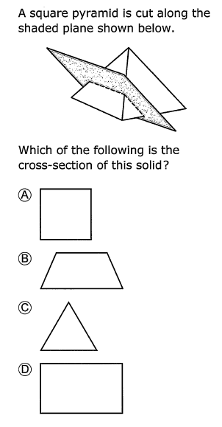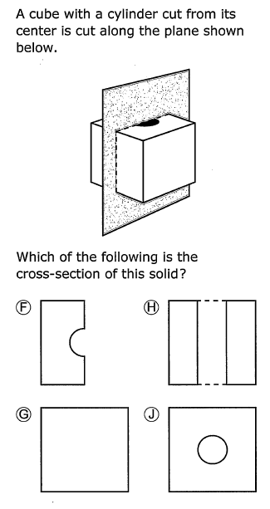 | 1. If a square pyramid was cut parallel to its base, what shape would the cross section be?  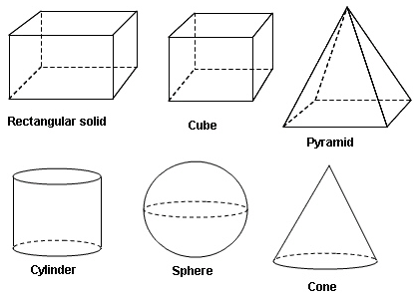  2. Which shape would have a circular cross section?
Rotations
Rotations are the 3 dimensional figure formed when rotating a 2 dimension figure about an axis. | What figure is formed when rotating the triangle about line m?  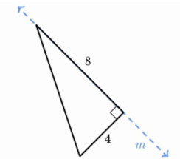  Cone with a height  of 8 units and  radius of 4 units. | 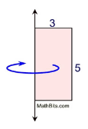  What figure is formed when rotating the rectangle about the line as shown?
Density
Density:  Density = quantity  Volume | A block of wood 3 cm on each side has a mass of 27 g. What is the density of the block?  v = l x w x h  v = 3 cm x 3 cm x 3cm  v = 27 cm³  D = m/v  D = 27 g / 27 cm³  Density = 1 g/cm³ | 1. A wooden block has a mass of 562 g and a volume of 72 cm³. What is the density?  2. A soda has a volume of 560 mL and a density of 3.2 g/mL. What is the mass?

