Graphing Quadratic Function

$$y =ax^{2}+bx+c$$

How do I know which way the parabola opens? _______________________________________________________

The formula to find the vertex and axis of symmetry is ____________________________

The solutions to a Quadratic function are also called ___________________, __________________, ________________,

Hits the ____________________ or ____________________.
The y-intercept is _____________________________.

Example 1: Graph f(x) = 2(x – 4)(x – 6)
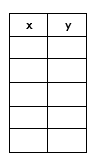
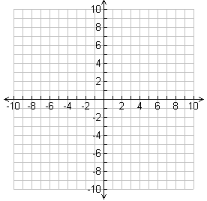

Opens: ___________________

x-int: ____________________

Vertex: ___________________

AOS: _____________________

y-Int: _____________________

Example 2: Graph f(x) = – (x + 1)(x – 5)

Opens: ___________________

x-int: ____________________

Vertex: ___________________

AOS: _____________________

y-Int: _____________________

- Graph f(x) = – (x + 2)(x – 4)

Opens: ___________________

x-int: ____________________

Vertex: ___________________

AOS: _____________________

y-int: _____________________

- Graph f(x) =2 (x + 3)(x – 1)

Opens: ___________________

x-int: ____________________

Vertex: ___________________

AOS: _____________________

y-int: _____________________

- Graph f(x) = – (x +4)(x – 2)

Opens: ___________________

Roots: ____________________

Vertex: ___________________

AOS: _____________________

Y-Int: _____________________

- Graph f(x) = – ½ (x + 2)(x – 4)

Opens: ___________________

Roots: ____________________

Vertex: ___________________

AOS: _____________________

Y-Int: _____________________

