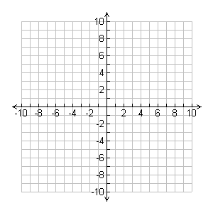
Function: ______________________________ 7)
a= ______ b= _______ c= ______
6) X Y
1) y-intercept: ______________
2) Axis of Symmetry: __________
3) Vertex: __________
4) The Parabola opens _____________ and
has a MINIMUM / MAXIMUM (circle one) value of __________
5) X-intercepts, roots, zeros, solutions: ________________

Quadratics Quick Sheet Name________________________ Date_________

Function: ______________________________ 7)
a= _______ b= _______ c= ______
6) X Y
1) y-intercept: ______________
2) Axis of Symmetry: ___________
3) Vertex: __________
4) The Parabola opens _____________ and
has a MINIMUM / MAXIMUM (circle one) value of __________
5) X-intercepts, roots, zeros, solutions: ________________

