Week 3 Warm Up Student Name:___________________________________________________________

|  |  |
| --- | --- |
| **Objective** | **Score** |
| 1 | A B NY |
| 2 | A B NY |
| 3 | A B NY |
| 4 | A B NY |
| 5 | A B NY |

ANSWERS:

|  |  |  |
| --- | --- | --- |
| **1.** | | |
| **2.** | | |
| **3.** | | |
| **4.** | | |
| **4/4 = 100** | **3/4 = 80** | **0-2 = NY** |
| **5.** | | |
| **6.** | | |
| **7.** | | |
| **8.**  **GRAPH** | | |
| **4/4 = 100** | **3/4 = 80** | **0-2 = NY** |
| **9.** | | |
| **10.** | | |
| **11.** | | |
| **12.** | | |
| **4/4 = 100** | **3/4 = 80** | **0-2 = NY** |
| **13.** | | |
| **14.** | | |
| **15.** | | |
| **16.** | | |
| **4/4 = 100** | **3/4 = 80** | **0-2 = NY** |
| **17.** | | |
| **18.** | | |
| **19.** | | |
| **20.** | | |
| **4/4 = 100** | **3/4 = 80** | **0-2 = NY** |

**Monday:**

1. Solve for b2:

2. Given: 18**,** would 0 be a solution?

3. Three less than 5 times Wanda’s age is the same as 3 times her age increased by 37. How old is she?

4. John’s bus ride to school is 7 minutes more than 1/2 the time of Zay’s bus ride. Write an equation to represent the time of John and Zay’s bus rides. If John’s bus ride is 17 minutes, how long is Zay’s bus ride?

**Tuesday:**

5. The length of a rectangle is 6 cm longer than the width. If the length is increased by 9 cm and the width by 5 cm, the perimeter will be 160 cm. Find the dimensions of the ORIGINAL rectangle.

6. Simplify: 

7. Find three consecutive odd integers such that the sum of 7 times the smallest and twice the largest is -91.

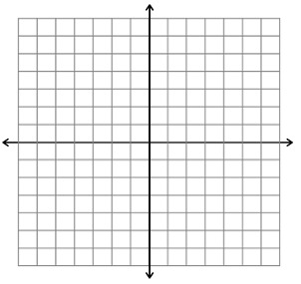

8. Using the graph at the right, create the line for: $y=\frac{-1}{2}x+4$

**Wednesday:**

9. Find the middle of 3 consecutive even integers such that the sum of twice the smallest integer half the middle integer is 106.

10. ; solve for h

11. What is the slope of the following graph?

1. 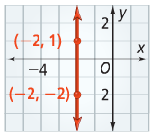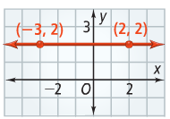 b.

12. Solve for x:

**Thursday:**

13. Bailey’s Gym charges members a joining fee of $130 and a monthly fee of $15. Gibby’s Gym charges members $25 a month, but no joining fee. After how many months will the two gyms cost the same amount?



14. Determine the Rate of Change:

15. The length of a rectangle is 3 times the width. The perimeter is 96cm. Find the length and width.

16. , solve for c.

**Friday:**

17. A media download stores sells songs for $1 each and movies for $12. You have a gift card for $60. Write an equation that describes the items you can purchase. What are three combinations of numbers of songs and movies you can purchase?

18. P = 2l + 2w, solve for w

19. Find three consecutive integers whose sum is 48.

20. Chip earns a base salary of $500 as a salesman. In addition to the salary, he earns $90 per product that he sells. If he wants to earn $5000 per month, how many products does he need to sell?