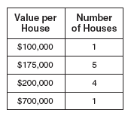**We Do**

Number of Cars

Value of Car

1) Find the following for the frequency table to the right:

$15,000

a) Mean __________ b) Median ______________

$20,000

c) Standard Deviation __________ d) Range ______________

$35,000

What would be the best measure of central tendency to use in this situation?

$125,000

2) Given the data set what percent of the height is **more than 2** feet different than the predicted height?

**You Do**

2

1

4

Number of Boats

Value of Boat

$30,000

1) Find the following for the frequency table to the right:

3

$35,000

a) Mean __________ b) Median ______________

$50,000

c) Standard Deviation __________ d) Range ______________

$75,000

What would be the best measure of central tendency to use in this situation?



2) Given the data set what percent of the height is **more than 2** feet different than the predicted height?

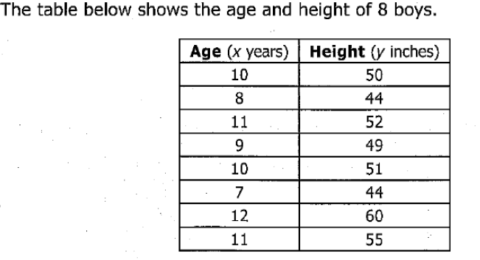3)

Approximately what percent of the boys were **more than 2** inches different from their predicted height?

4) These are the test scores for a student in Mr. Paulk’s Class. 5)

78, 84, 80, 68, 89, 82, 90

What would happen to the data distribution if the student

scored 90, 76, and 84 on the next three tests?

1. The data distribution would become less peaked and more widely spread.
2. The data distribution would become less peaked and less widely spread.
3. The data distribution would become more peaked and less widely spread.
4. The data distribution would become more peaked and more widely spread.

6) The following box and whisker plots represent the number of miles ran by Ms. Nelson in April and May. What conclusion can be drawn from the box-and-whisker plot below?

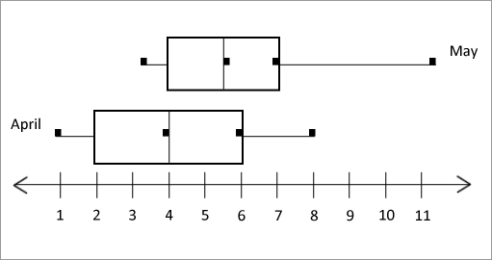

1. Ms. Nelson ran more miles in one run in April.
2. The Interquartile range of April is larger.
3. Ms. Nelson runs the same amount each month.
4. There is no conclusion that can be drawn from this data.